

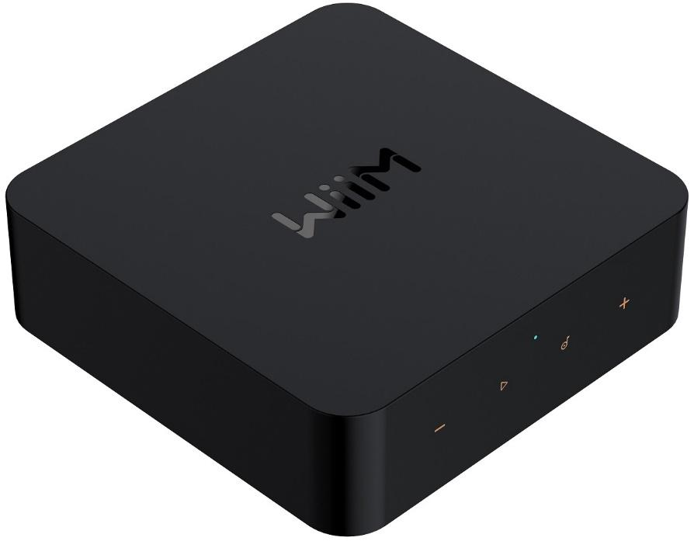

**WiiM Pro Plus: Hi-Res Music Streamer**

**Music Streamer Redefined**

**Table of Contents**

1. Introduction 3

Typical Use Cases 4

Other Devices Needed to Use the WiiM Pro Plus 6

Audio Devices Work with the WiiM Pro Plus 7

2. What's in the Box 8

3. Technical Specifications 9

4. WiiM Pro Plus Controls, Interfaces, and Lights 12

Front Panel Controls and Lights 12

Back Panel Interfaces 14

WiiM Voice Remote 16

LED Status Lights 18

5. How to Get Started 19

Connect the WiiM Pro Plus's Audio Output 20

Connect the WiiM Pro Plus's Audio Input 24

Use 12V Trigger Out 29

Power On the WiiM Pro Plus 30

Download and Install the WiiM Home App 31

Set Up the WiiM Pro Plus 32

Configure the WiiM Pro Plus in the WiiM Home App 45

Fill Your Home with Sound 46

6. WiiM Pro Plus Configuration 47

Select Audio Input Source and Configure Audio Input 47

Select Audio Output Interface 48

Adjust Audio Output Settings 50

Room Correction 51

Equalizer (EQ) 52

7. Audio Output/Input via Bluetooth 53

Audio Input via Bluetooth 53

Audio Output via Bluetooth 54

8. Voice Control 56

9. Direct Control via Your Favorite App 57

Spotify Connect 57

AirPlay 2 58

TIDAL Connect 59

Amazon Music Cast (Alexa Cast) 60

Google Cast Audio 61

DLNA 62

10. All Music in One App 63

11. Multi-room Audio and Stereo Pairing 64

WiiM Multi-room Audio/Stereo Pairing 64

AirPlay 2 Multi-room Audio 66

Amazon Alexa Multi-room Audio 67

Google Cast Multi-room Audio 68

12. Advanced Features 69

Firmware Updates 69

Use Ethernet Instead of Wi-Fi 69

13. FAQ and Support 70

FAQ 70

Support 72

14. Public Network Interfaces and Services 73

LAN Interface 73

Wi-Fi Interface 74

Bluetooth Interface 75

15. Important Safety Instructions 76

16. CE/FCC Statements 78

# Introduction

At WiiM, our goal is to offer you the simplest and most affordable Hi-Fi, lossless audio systems. Every product we create showcases top-tier design and an intuitive user interface.

With our patented audio streaming solution integrated into all our premium products and user-friendly mobile apps, you can effortlessly enjoy music throughout your entire home.

Introducing the WiiM Pro Plus, an exceptionally versatile network music streamer that stands out in the market. With features like Google Cast, AirPlay 2, Spotify Connect, TIDAL Connect, DLNA, Roon Ready, MQA, Alexa Cast, and seamless playback of Hi-Res 192k/24-bit lossless audio, it transforms your stereo system. Enjoy cloud-based music services or your own library via Wi-Fi or Ethernet.

It features a next-gen AKM 4493SEQ premium DAC, leveraging AKM’s Velvet Sound Technology to deliver industry-leading low distortion and wide dynamic range. It boasts a Signal-to-Noise Ratio (SNR) of 121 dB (A-wt) and a Total Harmonic Distortion plus Noise (THD+N) of -113 dB across sample rates from 44.1k to 192k, courtesy of its ultra-low noise clock and optimized power and circuit design. Additionally, it features a cutting-edge TI Burr-Brown PCM1861 ADC, which achieves a 110 dB SNR for analog-to-digital conversion, making it ideal for input sources like turntables, MP3 players, or TVs.

Simply plug the WiiM Pro Plus into your stereo receiver, DAC, or amplifier, and control it using the user-friendly WiiM Home App, popular platforms like Spotify, TIDAL, Amazon Music, or any Google Cast-enabled apps. Voice control is also a breeze through iPhone, HomePod, compatible Echo and Google Home devices, as well as the Alexa App, Google Home, or Apple Home app.

Create synchronized groups with HomePods, Echoes, Google Home, AirPlay 2 devices, other Alexa-compatible devices, or additional WiiM Minis, Pros or Pro Plus, streaming music throughout your home or playing different tracks in separate rooms. Boasting both digital and analog audio inputs and outputs, the WiiM Pro Plus seamlessly integrates with your existing stereo setup.

Elevate your audio gear with the smart capabilities of the WiiM Pro Plus, delivering high-fidelity, gapless music through the exceptional innovation of WiiM.

## Typical Use Cases

The WiiM Pro Plus is designed to enhance your existing audio setup by adding wireless streaming capabilities and smart features. Here are a few common use cases for the WiiM Pro Plus:

* + **Upgrade your Favorite Legacy Audio Systems**: If you have a traditional stereo system or speakers that you want to integrate into your Apple AirPlay 2, Google Cast, Amazon Alexa or LinkPlay ecosystem, the WiiM Pro Plus allows you to wirelessly stream music to those speakers. It bridges the gap between your older audio equipment and the modern world of streaming music.
  + **High-Quality Audio**: It supports bit-perfect, high-resolution audio formats and delivers rich, detailed sound, enhancing the listening experience of your existing audio system.
  + **Streaming Services and Music Libraries**: The WiiM Pro Plus allows you to access various streaming services such as Spotify, Amazon Music, or TIDAL, bringing a wide range of music to your existing audio setup. You can also connect it to your personal music library stored on a computer or network-attached storage device for seamless playback.
  + **Podcasts and Internet Radio**: In addition to streaming music, the WiiM Pro Plus provides access to a wide range of podcasts and internet radio stations. You can browse through different genres, podcasts, or specific radio stations to enjoy on your existing audio system.
  + **Multi-room Audio**: The WiiM Pro Plus seamlessly integrates with other 3rd party popular smart speakers and components, or another WiiM/Linkplay device, allowing you to create a whole-home audio system with synchronized music playback in multiple rooms.
  + **Smart Home Integration**: The WiiM Pro Plus supports voice control through platforms like Apple Siri, Amazon Alexa or Google Assistant, allowing you to control your music hands-free and integrate with other smart home devices.
  + **Vinyl or CD Integration**: If you have a turntable or CD player that you want to incorporate into your WiiM or AirPlay system, the WiiM Pro Plus can connect to the analog or digital outputs of these devices. This enables wireless audio streaming to other speakers via another WiiM or AirPlay compatible device, allowing you to relish the sound throughout your entire home, all in sync.
  + **Home Theater Integration**: The WiiM Pro Plus can be used as a bridge between your home theater system and the WiiM ecosystem. By connecting the Pro Plus to your AV receiver or soundbar, you can stream music wirelessly to your home theater speakers and synchronize audio playback with other WiiM devices for a cohesive audio experience.

## Other Devices Needed to Use the WiiM Pro Plus

To use the WiiM Pro Plus, you will need a few essential devices and components. Here's a list of what you'll need:

* + **Audio System**: The WiiM Pro Plus is designed to connect to an existing audio system. This can be a stereo system, powered speakers, passive speakers with an amplifier/receiver, or a home theater setup with an AV receiver or soundbar. Make sure you have the appropriate audio system in place.
  + **Wi-Fi Network**: The WiiM Pro Plus requires a stable Wi-Fi network connection to function. Ensure that you have a reliable Wi-Fi network available in the area where you plan to set up the WiiM Pro Plus. You'll need the Wi-Fi network credentials during the setup process.
  + **Smartphone or Tablet**: You'll need a compatible smartphone or tablet (iOS or Android) with the WiiM Home app installed. The WiiM Home app is used for initial setup, configuration, and control of the WiiM Pro Plus.
  + **Power Source**: The WiiM Pro Plus needs to be connected to a power source using the included power adapter and cable. Ensure that you have an electrical outlet nearby to power the device.
  + **Ethernet Cable** (optional): While the WiiM Pro Plus primarily connects to your Wi-Fi network, it also has an Ethernet port. If you prefer a wired connection for added stability, you can use an Ethernet cable to connect the WiiM Pro Plus directly to your router or network switch.

These are the core components required to use the WiiM Pro Plus. It's important to have an audio system that you want to integrate with the WiiM Pro Plus, a stable Wi-Fi network, and a compatible device with the WiiM Home app for setup and control.

## Audio Devices Work with the WiiM Pro Plus

The WiiM Pro Plus can work with your audio source devices, smart speakers and other legacy stereo systems, DAC, amplifier, speakers or soundbars etc. The audio source device includes TV, record player and MP3 player. The diagram below shows how you can connect your audio system with the WiiM Pro Plus.

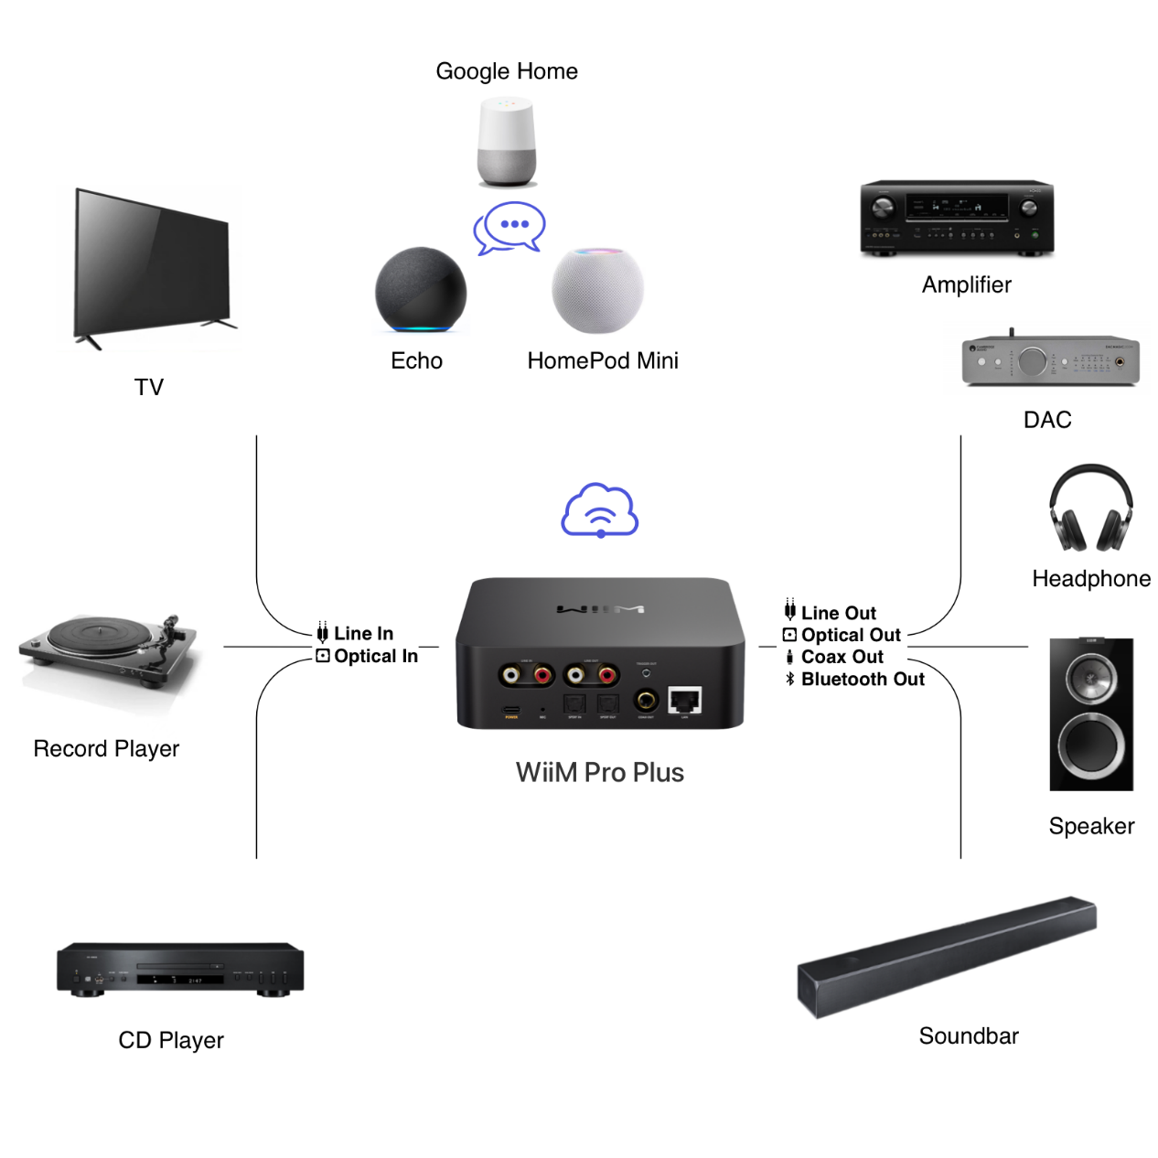

# What's in the Box

|  |  |  |
| --- | --- | --- |
| 1. | WiiM Pro Plus | x 1 |
| 2. | WiiM Voice Remote | x 1 |
| 3． | Quick start guide | x 1 |
| 4. | USB power adapter (5V, 2A) | x 1 |
| 5. | RCA audio cable (1.5m) | x 1 |
| 6. | USB Type-C cable (1.5m) | x 1 |
| 7. | Optical audio cable (1.5m) | x 1 |
| 8. | 2.5 mm to 3.5 mm trigger out converter | x 1 |

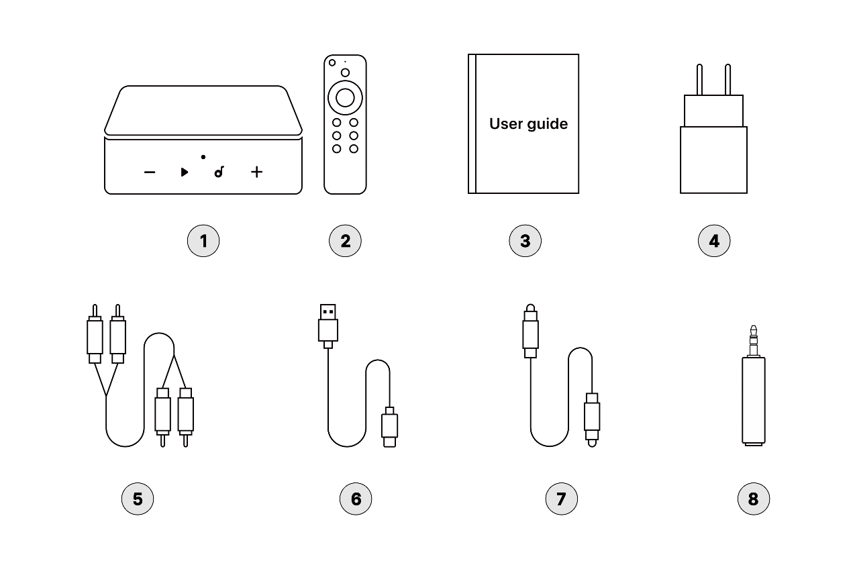

# Technical Specifications

|  |  |
| --- | --- |
| Category | Specification |
| Audio Amplification | No |
| Main Purpose | Connected to amplifier or powered speaker for streaming |
| Pair with a Sub | No |
| USB Port (Storage/Audio Out) | No |
| Wireless Connectivity | Wi-Fi 5 |
| Bluetooth | BT 5.0 |
| Ethernet | Yes |
| DAC IC | AKM 4493SEQ |
| Analog Out SNR | 121 dB |
| THD+N (Analog Out) | -113dB (0.00023%) |
| Analog Input (ADC) | Up to 192k, 24 bit |
| Google Cast Audio | Yes |
| Group with Nest Speakers and Display | Yes |
| Group with Echo Speakers and Display | Yes |
| Alexa Multi-room with UHD | Yes |
| Group with HomePods | Yes |
| Work with Alexa | Yes |
| Works with Google | Yes |
| Works with Siri | Yes |
| Group with WiiM Devices | Yes |
| AirPlay 2 | Yes |
| 2-Way Bluetooth | Yes |
| Roon Ready | Yes |
| DLNA | Yes |
| Spotify Connect & TIDAL Connect | Yes |
| Gapless Playback | Yes |
| 10-band Graphic and Parametric EQ | Yes |
| Room Correction | Yes |
| WiiM Music Streaming Platform | Yes |
| CPU | Quad Core A53 |
| DRAM | 512 MB |
| Flash | 512 MB |
| Audio Input Ports | Line In:   * 1 Vrms * Analog signal, converted to digital via ADC (48 kHz/16-bit) |
| SPDIF In:   * Up to 192kHz/24-bit * Supports Stereo PCM (Dolby Digital and DTS are not supported) |
| Audio Output Port | Line-Out |
| SPDIF Out (up to 192 kHz/24-bit) |
| COAX Out (up to 192 kHz/24-bit) |
| LED | Three-color status LED - Red, Green, and White |
| Control | Capacitive touch buttons:   * Play/Pause * Volume **＋** * Volume **－** * Preset |
| Weight | 14.1 oz (400g) |
| Dimension | 5.5 x 5.5 x 1.6 in (140 x 140 x 42 mm) |
| Power Input | USB Type-C: requires 5V, 1.5A or higher  Bundled USB power adapter: 5V, 2A |

# WiiM Pro Plus Controls, Interfaces, and Lights

## Front Panel Controls and Lights

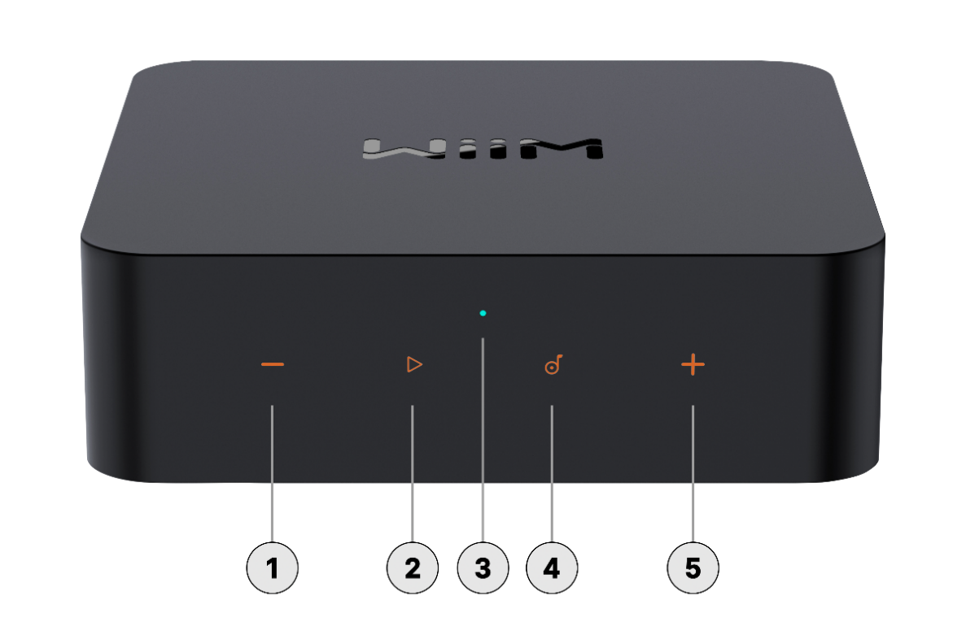

Each numbered control or light on the front panel is explained below:

|  |  |  |
| --- | --- | --- |
|  | **Volume –** | Press to decrease volume. |
|  | **Play/Pause** | Start or pause the playback.  Wi-Fi setup (push and hold for 3 seconds)  Restore to the factory setting (push and hold for 10 seconds) |
|  | **Status LED** | A three-color LED (RGW) indicator to display the operational status of the WiiM Pro Plus.  For more information, see LED Status Lights. |
|  | **Preset** | Tap to play a preset.  Tap repeatedly to cycle through all presets. |
|  | **Volume ＋** | Press to increase volume.  Press and hold the **Volume +** and **Volume –** buttons together for 2 seconds to initiate Bluetooth pairing. For more information, see Audio Input via Bluetooth. |

## Back Panel Interfaces

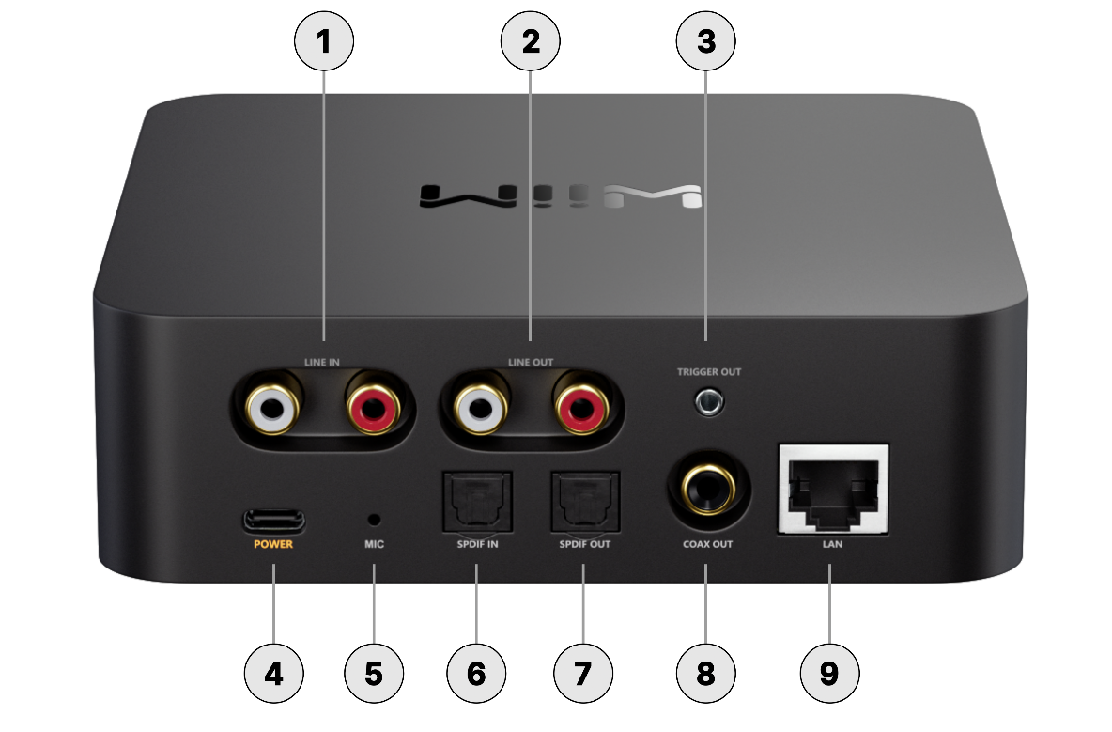

Each numbered interface on the back panel is explained below:

|  |  |  |
| --- | --- | --- |
|  | **LINE IN** | Connects to external audio sources such as CD players, audio players, and TVs for analog audio input. |
|  | **LINE OUT** | Outputs analog audio, ideal for connecting to an external amplifier, powered speakers, or audio receiver. |
|  | **12V TRIGGER OUT** | 2.5 mm port for cable connection to your amplifier for automated power control.  ***Note:*** *Consult your amplifier's user guide for specifics on utilizing its 12V trigger input.* |
|  | **Power Input** | USB Type-C power plug (5V, 2A)  ***Note:*** *This USB Type-C interface is for power input only. It does not support USB storage or USB audio output.* |
|  | **MIC** | Used to auto-measure the audio path latency for multiroom sync (i.e., AirPlay 2, Alexa MRM, Google Cast MRM, WiiM MRM, etc.). The MIC is engaged only during latency measurement. |
|  | **SPDIF IN** | Connects to external audio sources, such as a TV or PC, for digital audio input. It supports audio input of up to 192 kHz/24-bit. |
|  | **SPDIF OUT** | Outputs high-quality digital audio up to 192 kHz/24-bit with low jitter. |
|  | **COAX OUT** | Outputs digital audio up to 192 kHz/24-bit with low jitter. |
|  | **LAN** | 10/100Mbps Ethernet port |

## WiiM Voice Remote

You can use the WiiM Voice Remote to effortlessly control the WiiM Pro Plus. For detailed instructions, refer to [How to Set Up Your WiiM Voice Remote](https://faq.wiimhome.com/en/support/solutions/articles/72000596656-how-to-set-up-your-wiim-voice-remote-).

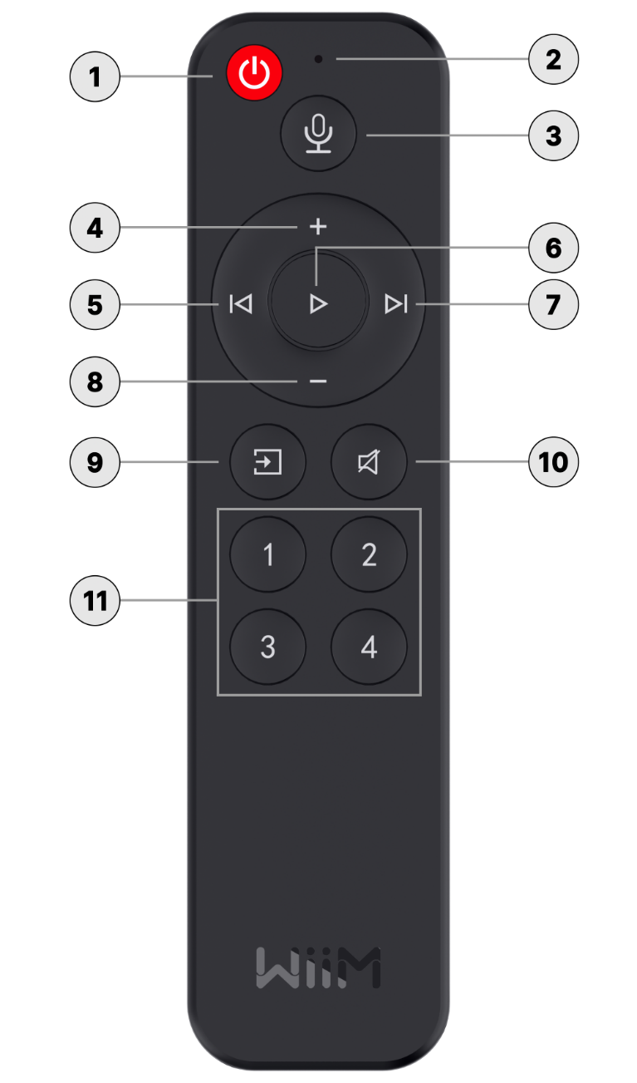

Each numbered control on the WiiM Voice Remote is explained below:

|  |  |  |
| --- | --- | --- |
|  | **Standby** | Press to put the WiiM Pro Plus into standby mode. |
|  | **Microphone** | Capture voice commands. |
|  | **Voice Control** | Press and hold to give voice commands. |
|  | **Volume Up** | Press to increase the speaker volume. |
|  | **Previous** | Press to return to the previous playback or restart the current playback. |
|  | **Play/Pause** | Press to start or pause the current playback. |
|  | **Next** | Press to skip to the next playback. |
|  | **Volume Down** | Press to decrease the speaker volume. |
|  | **Source Switch** | Press to change the input source. |
|  | **Mute/Unmute** | Press to mute or unmute the speakers. |
|  | **Preset Shortcuts** | Press buttons 1~4 to play the corresponding presets. |

## LED Status Lights

|  |  |  |
| --- | --- | --- |
| **LED Color/Pattern** | | **State** |
| Fast Flashing White |  | Boot-up |
| Slow Flashing White |  | OOBE/Ready to setup |
| Slow Flashing Green |  | Bluetooth ready to pair |
| Fast Flashing White and Green |  | Connecting to Wi-Fi |
| Solid White |  | Connected to Wi-Fi |
| Solid Green |  | Bluetooth mode, paired |
| Solid Light Green |  | Line-in mode |
| Solid Orange |  | SPDIF-in mode |
| Slow Flashing White and Green |  | OTA update |
| Slow Flashing White and Red |  | Restore to factory settings |
| Solid Yellow |  | No network |
| Slow Flashing Red |  | Faulty error |

# How to Get Started

Before using your WiiM Pro Plus, follow these main steps to set it up:

* 1. Connect the WiiM Pro Plus to your audio device.
  2. Power on the WiiM Pro Plus.
  3. Download and install the WiiM Home app on your mobile device.
  4. Use the WiiM Home app to connect the WiiM Pro Plus to your network.
  5. Configure the WiiM Pro Plus in the WiiM Home app to suit your preferences.

By completing these steps, your WiiM Pro Plus will be ready for use. The following sub-chapters will provide detailed instructions for each step.

## Connect the WiiM Pro Plus's Audio Output

The WiiM Pro Plus features three distinct audio output interfaces:

* + Analog Line Out
  + Digital SPDIF Out
  + COAX Out

Besides audio output via the above physical interfaces, the WiiM Pro Plus can also output audio via Bluetooth. For detailed instructions, see Audio Output via Bluetooth.

**Notes**:

* + *The WiiM Pro Plus is designed to output audio through a single one of these audio output interfaces.*
  + *Selecting the appropriate audio output port is crucial to ensure sound output. Incorrect selection may result in no audio.*
  + *For bit-perfect audio output, opt for the digital audio output and activate the* ***Fixed Volume Output****, disable EQ and mono audio in the WiiM Home app's device settings.*
  + You have two ways to control the volume of your system:
* Utilize your AVR or amplifier for volume control (When the **Fixed Volume Output** is set on the WiiM Pro Plus).
* Control volume through the WiiM Home app, but remember to disable the **Fixed Volume Output** for this option.

### Scenario 1: Line Out (Powered Speakers, Amplifiers, AV Receivers)

The **LINE Out** interface on the WiiM Pro Plus is typically used to connect to the external audio equipment, e.g., powered speakers, amplifiers, or AV receivers to output high-quality analog audio playback.

**Cable Requirement:** Use an RCA stereo cable as below:

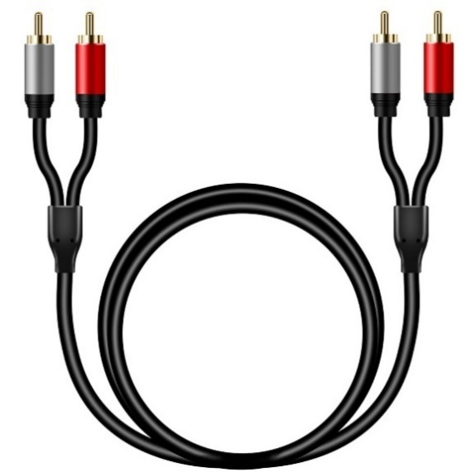

**Cable Connection Steps**:

1. Connect the red and white RCA connectors on one end of the cable to the corresponding **Line Out** ports on the WiiM Pro Plus.
2. Connect the red and white RCA connectors on the other end of the cable to the corresponding **Line In** ports on your external device.

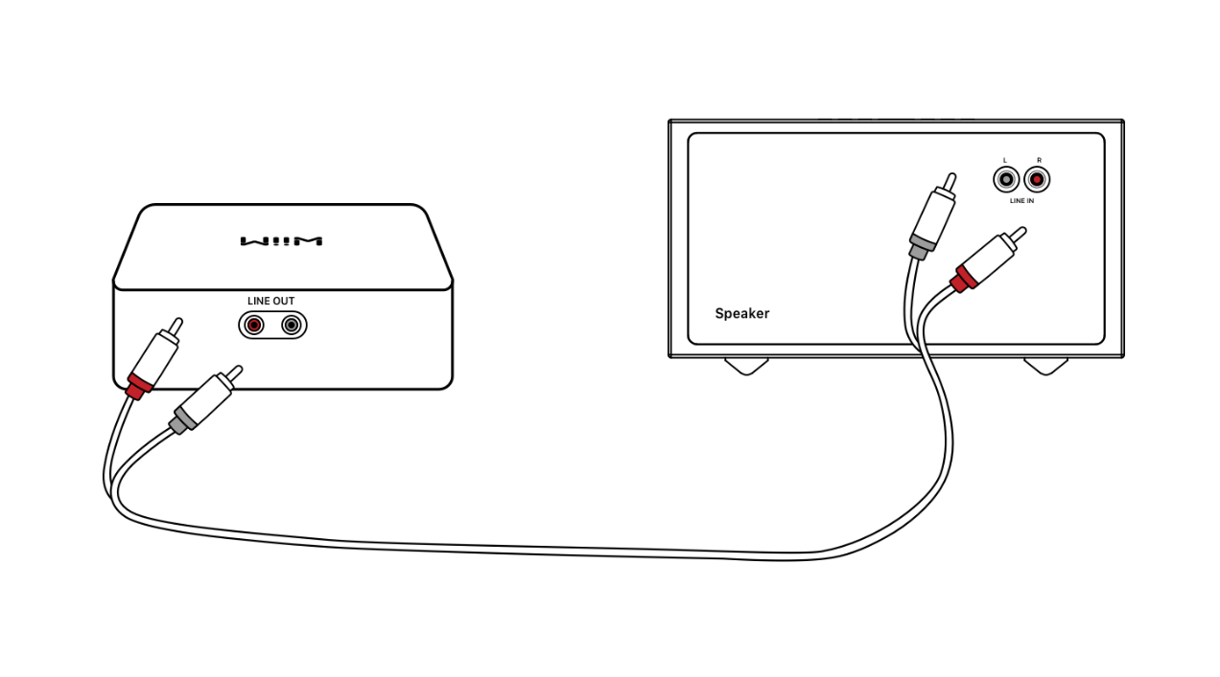

### Scenario 2: SPDIF Out (Soundbars, DACs, or AV Receivers)

The **SPDIF Out** interface on the WiiM Pro Plus is typically used to connect to the external device, e.g., soundbars, DACs, or AV receivers, to output digital audio playback.

**Cable Requirement:** Use a TOSLINK optical cable as below:

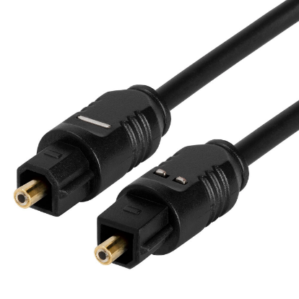

**Cable Connection Steps**:

1. Plug one end of the optical cable into the **SPDIF Out** port on the WiiM Pro Plus.  
    ***Note****: Please ensure the insertion direction of the optical cable matches the port. Incorrect insertion may damage the optical door.*
2. Plug the other end of the cable into the **SPDIF In** or **Optical In** port of your external device.

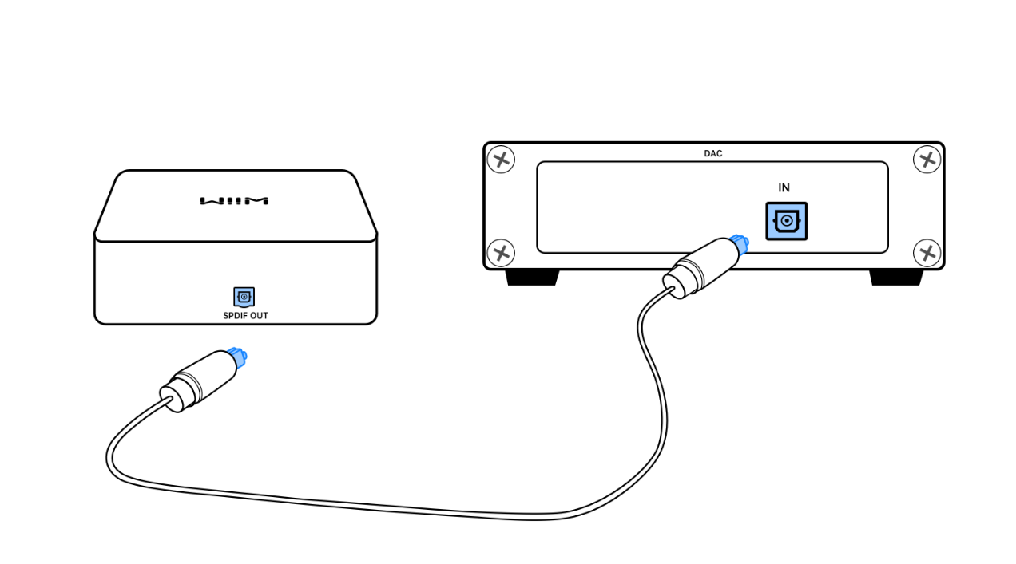

### Scenario 3: COAX Out (DACs, AV Receivers, or Amplifiers)

The **COAX Out** interface on the WiiM Pro Plus is typically used to connect to the external device, e.g., DACs, AV receivers, or amplifiers supporting coaxial input.

**Cable Requirement:** Use a Coaxial digital audio cable with 75-ohm impedance as below:

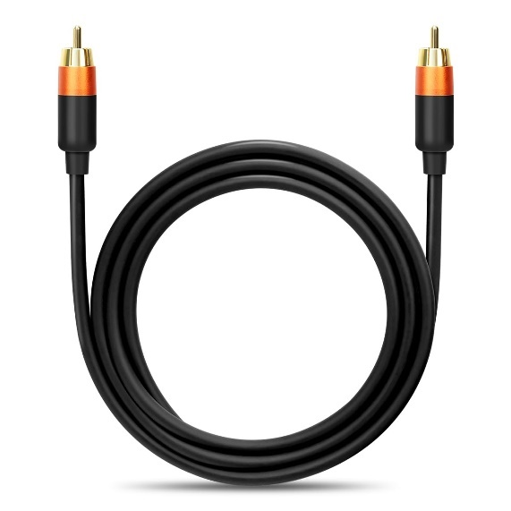

**Cable Connection Steps**:

1. Plug one end of the coaxial cable to the **COAX Out** port on the WiiM Pro Plus.
2. Plug the other end of the cable to the **COAX In** port of your external device.

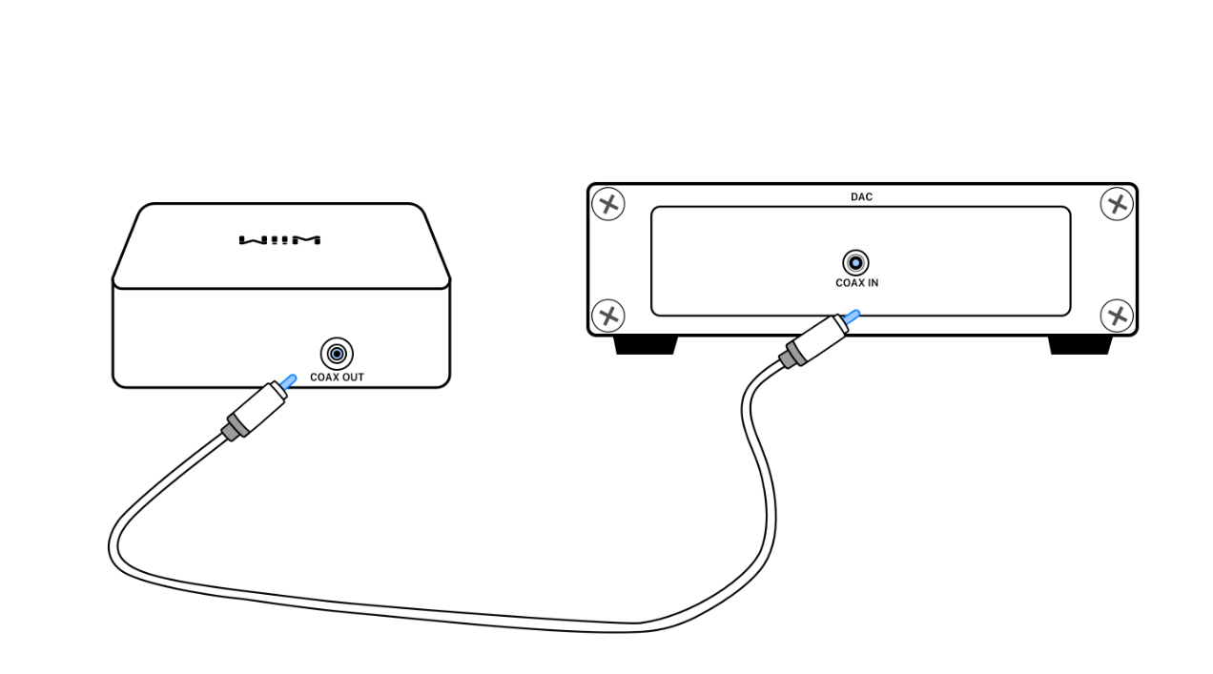

## Connect the WiiM Pro Plus's Audio Input

The WiiM Pro Plus features two distinct audio input interfaces:

* + Analog Line In
  + Digital SPDIF In (TOSLINK)

This versatile device functions as a network audio transmitter through Wi-Fi or Ethernet. You have the capability to stream analog audio input from sources such as CD players, vinyl players, TVs, or computers to other WiiM devices, either individually or in multiple combinations.

In addition to physical input interfaces mentioned above, you can also stream audio from an external device (e.g., smartphones or tablets) to the WiiM Pro Plus via Bluetooth. For detailed instructions, see Audio Input via Bluetooth.

**Notes:**

* + *The* ***SPDIF In*** *interface on the WiiM Pro Plus only support* ***PCM*** *audio format. Please ensure that the audio source device connected to the WiiM Pro Plus is set to output audio in* ***PCM*** *format. Otherwise, you may not hear sound.*
  + *You can also enable the* ***Auto-sensing*** *feature on the WiiM Pro Plus to automatically play your* ***Line In*** *or* ***SPDIF In*** *source when the WiiM Pro Plus detects a signal. You can enable this feature from the WiiM Home app.*
  + *The WiiM Pro Plus has a built-in EQ to process the audio input based on your taste. You can also control the audio volume using the WiiM Home app remotely without altering the input source volume.*
  + *Some source devices may require a preamp. For example, some turntables do not have a built-in preamp, so you will need to connect your turntable to an external preamp first, and then connect the preamp to the WiiM Pro Plus.*

### Scenario 1: Analog Line In Audio Source Input (CD Player, Turntable with a Built-in Preamp, or PC)

The **Line In** interface on the WiiM Pro Plus is typically used to connect to a CD Player, Turntable with a built-in preamp, or PC to receive analog audio input.

**Cable Requirement**: One of the following two types of cables might be used.

* An RCA-to-RCA cable as below:  
    
  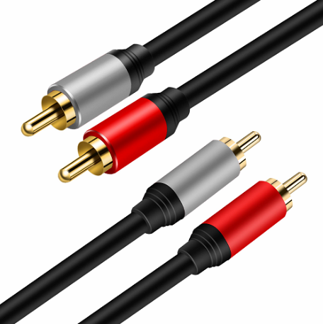
* An Aux-to-RCA cable as below:  
    
  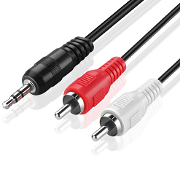

**Cable Connection Steps:**

1. Plug RCA connectors on one end of the cable into the **Line In** port on the WiiM Pro Plus.
2. Plug the other end of the cable into the **AUX** or **Line Out** port on your audio source (CD player, turntable, TV, or PC).

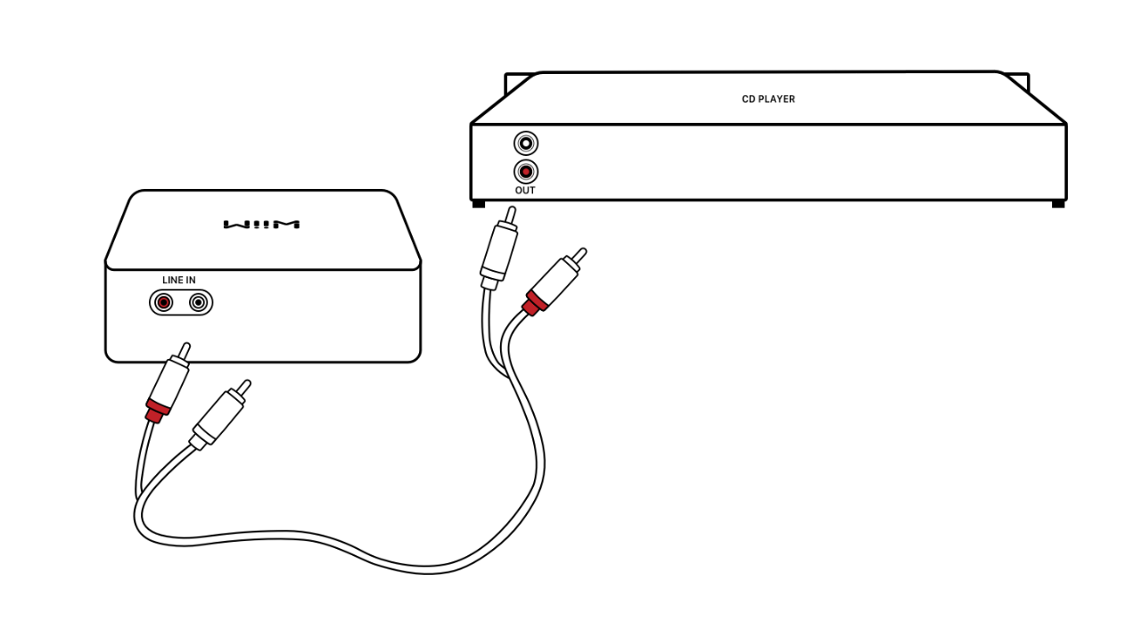

### Scenario 2: SPDIF In Audio Source Input (TV or PC)

The **SPDIF In** interface on the WiiM Pro Plus is typically used to connect to a TV or PC to receive digital audio input.

**Cable Requirement**: use a TOSLINK optical cable as below:  
  


**Cable Connection Steps**

1. Plug one end of the optical cable into the **SPDIF In** port on the WiiM Pro Plus.  
    ***Note****: Please ensure the insertion direction of the optical cable matches the port. Incorrect insertion may damage the optical door.*
2. Plug the other end into the **SPDIF Out** or **Optical Out** port on the TV or PC.

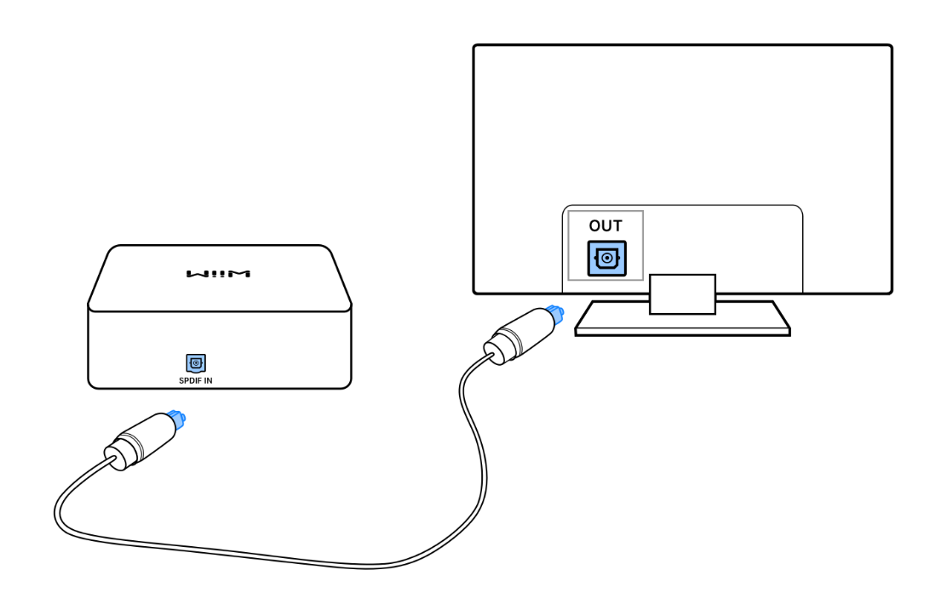

**Note:** *The* ***SPDIF In*** *interface on the WiiM Pro Plus only supports* ***PCM*** *audio format. Please ensure that the audio source device connected to the WiiM Pro Plus is set to output audio in* ***PCM*** *format. Otherwise, you may not hear sound.*

## Use 12V Trigger Out

You can use the **12V Trigger Out** port on the WiiM Pro Plus to automatically power on or off external audio devices, such as amplifiers or DACs, based on the WiiM Pro Plus's status.

To achieve this, connect the **12V Trigger Out** port on the WiiM Pro Plus to the **12V Trigger In** port on the external audio device using a compatible cable.

For more information, refer to [How to Use the 12V Trigger Out](https://faq.wiimhome.com/en/support/solutions/articles/72000602073-how-to-use-the-12v-trigger-on-wiim-pro-wiim-pro-plus-or-wiim-ultra-).

## Power On the WiiM Pro Plus

Please use the provided USB power adapter (5V, 2A) and USB Type-C cable to power your WiiM Pro Plus. If you want to use your own linear power supply, please ensure it can provide at least at least 5 V and 1.5 A.

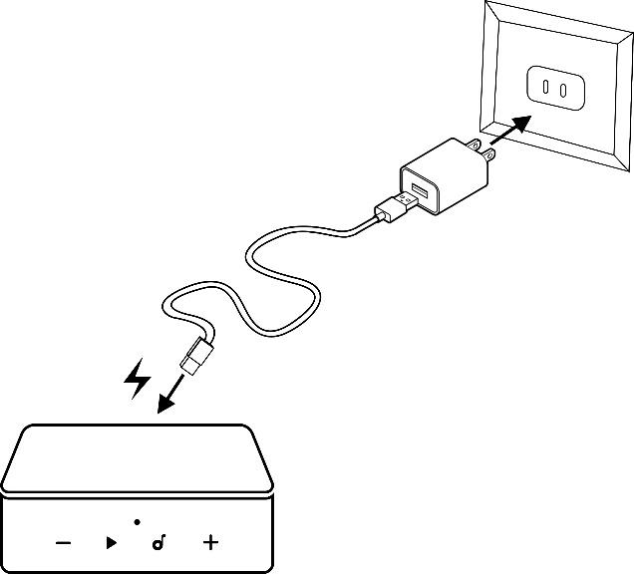

After powering on the WiiM Pro Plus, wait 30 seconds for it to fully boot up before starting the setup process.

## Download and Install the WiiM Home App

* For an iOS or Android device, scan the following QR code to download the app:

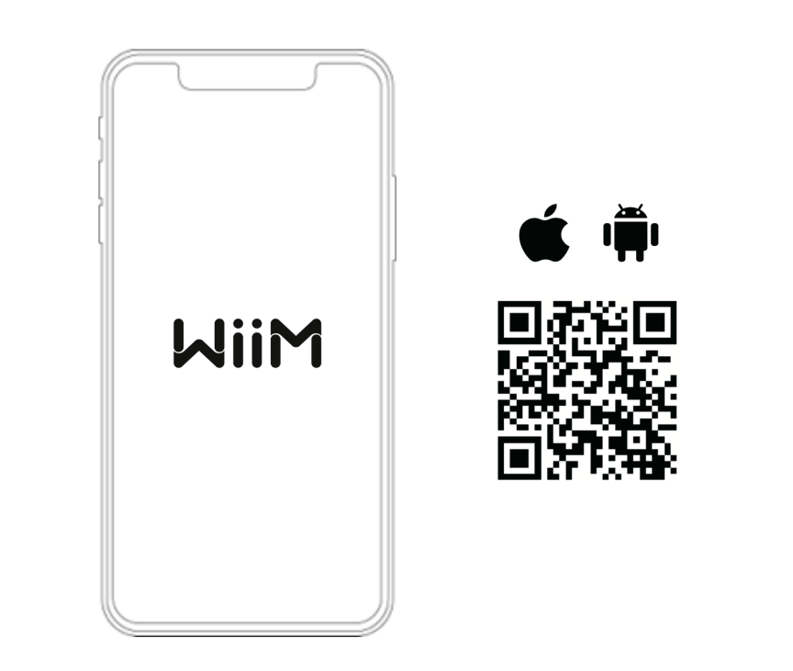

* The beta version is also available for Windows and Mac OS. Download it [here](https://wiimhome.com/app).

## Set Up the WiiM Pro Plus

You can set up the WiiM Pro Plus via Wi-Fi or Ethernet using the WiiM Home app. If you choose to connect via Wi-Fi, make sure you have the network password ready. This will ensure a smooth and efficient setup process.

If you use an iOS device, you can also use the Apple Wireless Accessary Configuration (WAC) protocol or the Apple Home app to set up the WiiM Pro Plus.

### WiiM Pro Plus Setup via Wi-Fi Using WiiM Home App

1. Open the WiiM Home app on your smartphone or tablet.
2. When the **Set Up** pop-up appears in the app, tap it to start the setup.   
   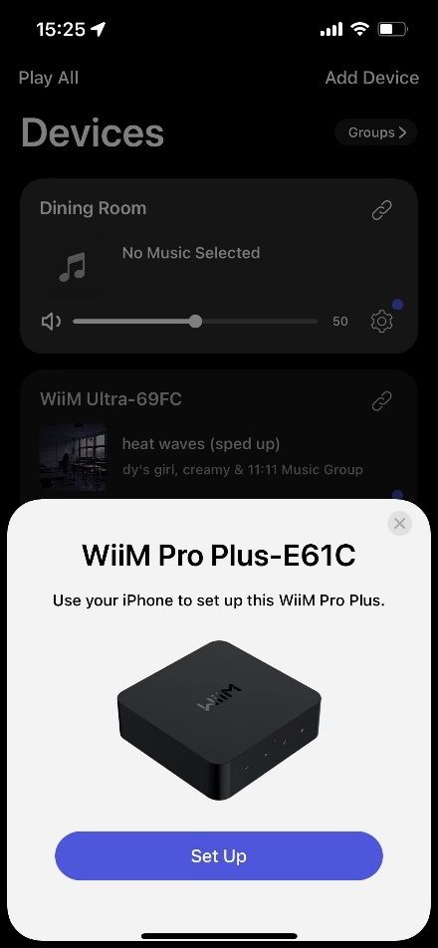
3. Follow the on-screen instructions to complete the setup:
4. Select the right audio output interface corresponding to the output connection in Connect the WiiM Pro Plus’s Audio Output.  
   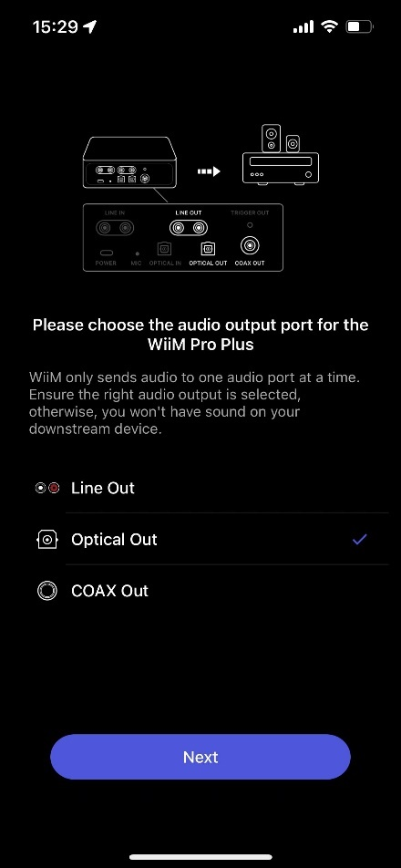
5. Connect the WiiM Pro Plus to the same Wi-Fi network as WiiM Home.  
   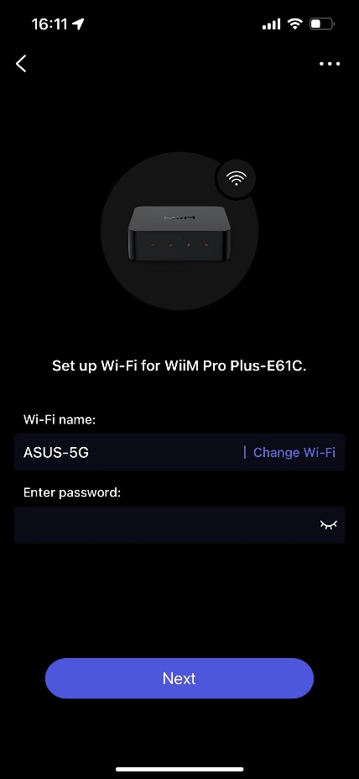
6. Check and update the firmware.  
   
7. Rename the WiiM Pro Plus.  
   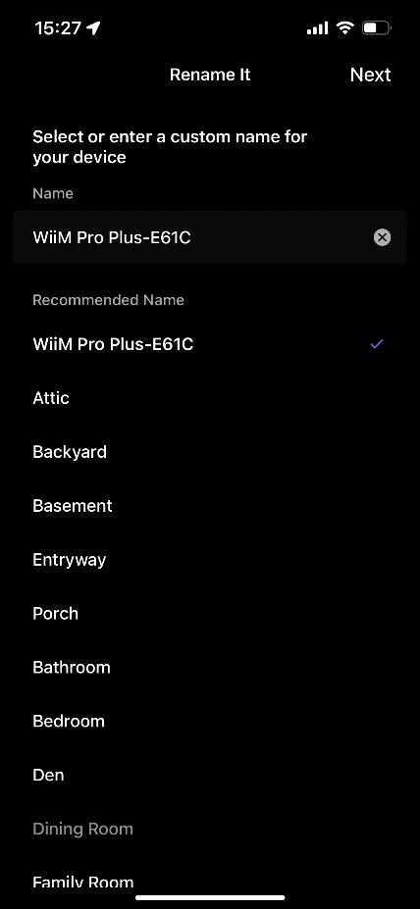
8. Set up the WiiM Voice Remote with the WiiM Pro Plus.   
   For detailed instructions, refer to [How to Set Up Your WiiM Voice Remote](https://faq.wiimhome.com/en/support/solutions/articles/72000596656-how-to-set-up-your-wiim-voice-remote-).  
   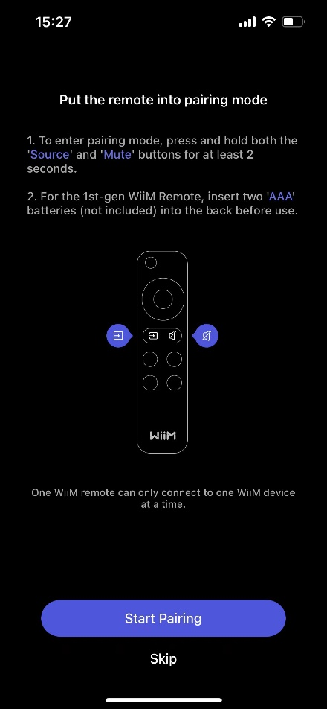
9. Calibrate the audio path latency.  
   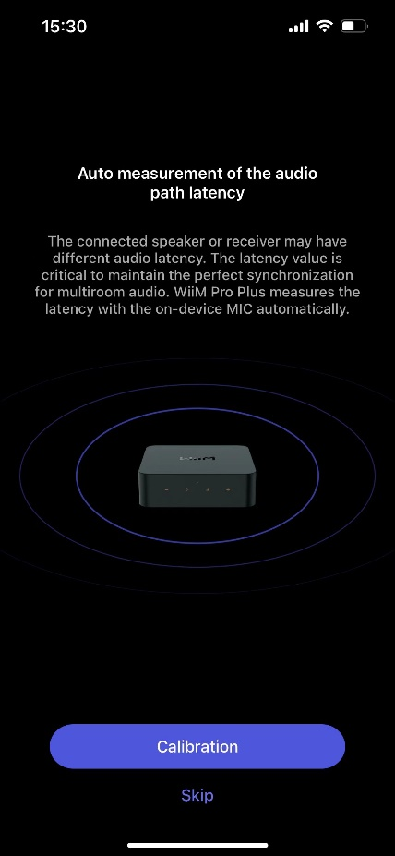
10. Configure sample rate for the optical/SPDIF output.  
    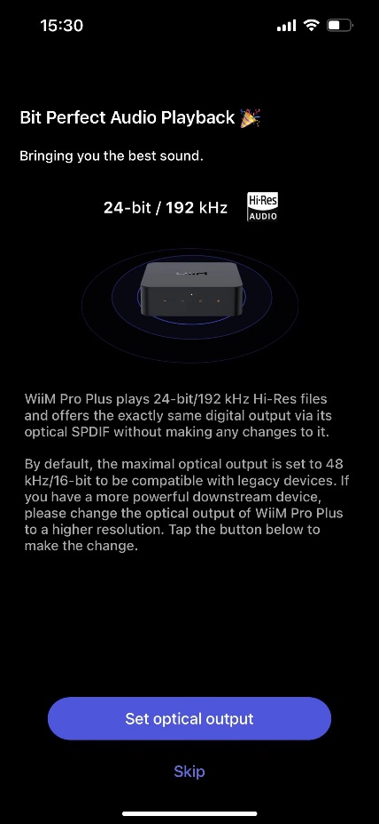
11. Set up Google Cast, Alexa and add to Apple Home.  
    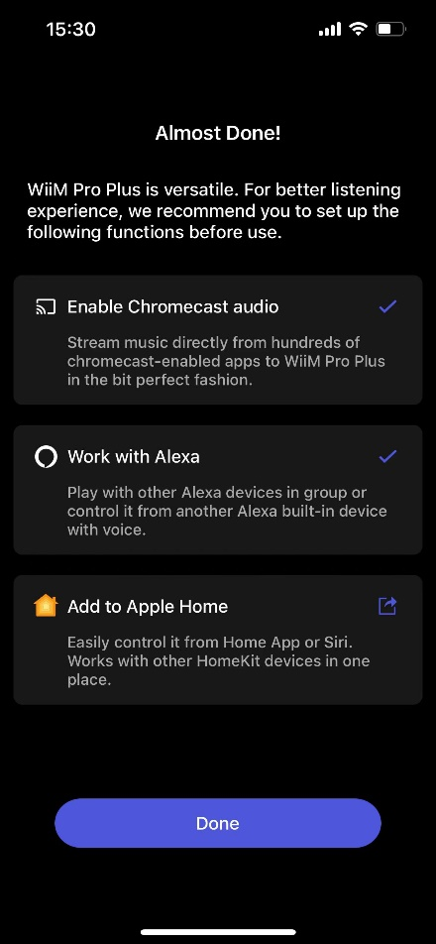

### WiiM Pro Plus Setup via Ethernet Using WiiM Home App

1. Connect an Ethernet cable to the WiiM Pro Plus.
2. Open the WiiM Home app on your smartphone or tablet.
3. When the **Let’s Get Started** pop-up appears in the app, tap it to start the setup.  
     
   ***Note****: If the* ***Let’s Get Started*** *pop-up does not appear, tap* ***Add Device*** *in the top-right corner to trigger it.*  
   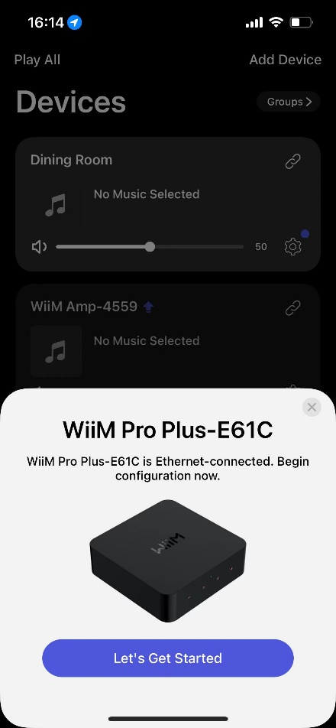
4. Follow the on-screen instructions to complete the setup.

### WiiM Pro Plus Setup Using Apple WAC

1. Open the **Settings** app on your iOS device.
2. Tap the **WLAN** option.
3. Select the WiiM Pro Plus under the **SET UP NEW AIRPLAY SPEAKER** section.  
   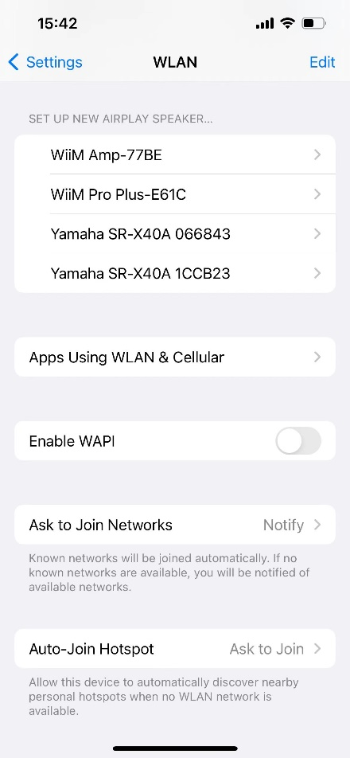
4. Follow the on-screen instructions to complete the setup.

### WiiM Pro Plus Setup Using Apple Home App

1. Open the Home app on your iOS device.
2. Tap the **+** icon in the top-right corner of the screen. A new menu will pop up.
3. Select the **Add or Scan Accessory** option from the menu.  
   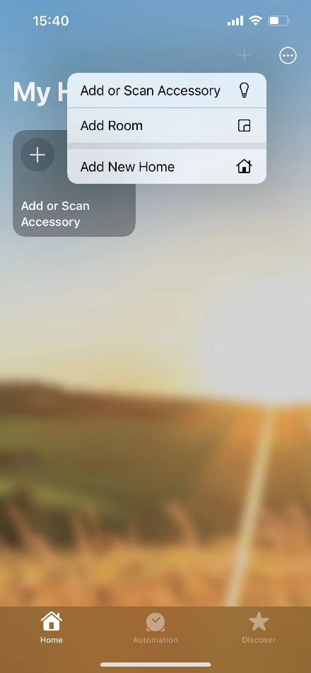
4. Select **More options...**in orange.  
   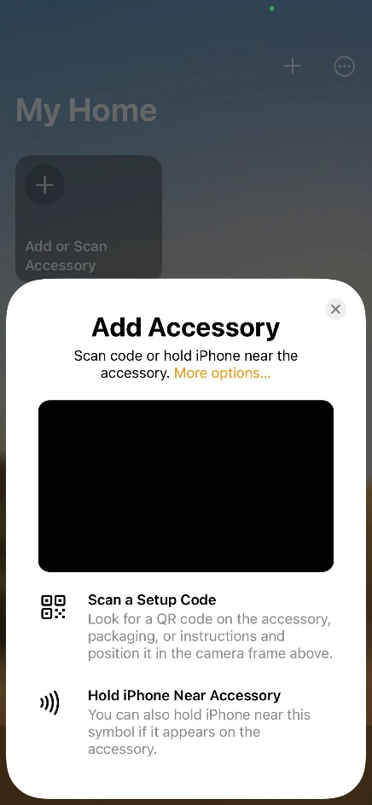
5. Choose the WiiM Pro Plus from the list.  
   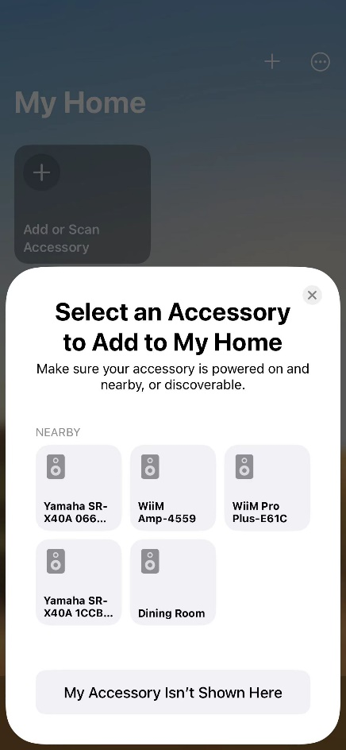
6. Follow the on-screen instructions to complete the setup.

## Configure the WiiM Pro Plus in the WiiM Home App

Once the WiiM Pro Plus is set up, configure it in the WiiM Home app, including settings for audio input, audio output, room correction, and EQ adjustments.

For detailed instructions, see WiiM Pro Plus Configuration.

## Fill Your Home with Sound

Now, play music from your favorite audio sources, including a TV, amplified turntable, CD player, or MP3 player. Alternatively, enjoy seamless streaming of your favorite music and radio stations over Wi-Fi or Bluetooth.

The WiiM Pro Plus can be grouped with other WiiM devices to create a synchronized music experience across your home. You can further expand your listening experience by grouping the WiiM Pro Plus with AirPlay 2-enabled, Alexa-enabled, or Google Cast-enabled devices, enabling a seamless multi-room audio system. For more information, see Multi-room Audio and Stereo Pairing.

# WiiM Pro Plus Configuration

## Select Audio Input Source and Configure Audio Input

1. Open the WiiM Home app.
2. Navigate to the **Devices** tab.
3. Tap the **Device Settings** icon  of the WiiM Pro Plus.
4. Under the **Sound** section, select **Audio Input**.
5. Select the audio input source and adjust related settings.  
   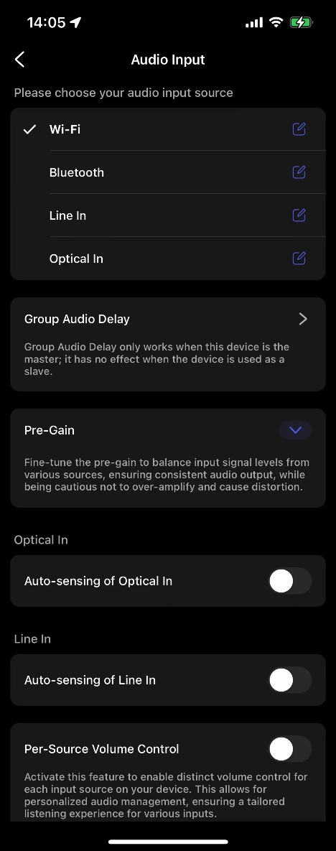

## Select Audio Output Interface

**Option 1: Select Audio Output Interface from Now Playing**

1. Open the WiiM Home app.
2. Go to the **Now Playing** page.
3. Tap the  icon at the bottom and select the output interface.  
     
   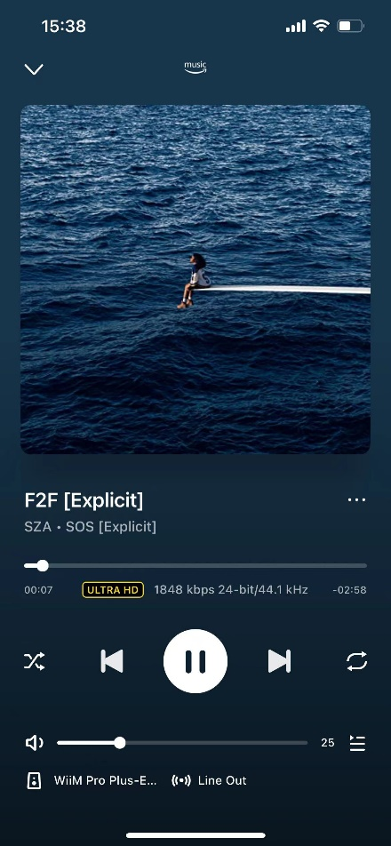 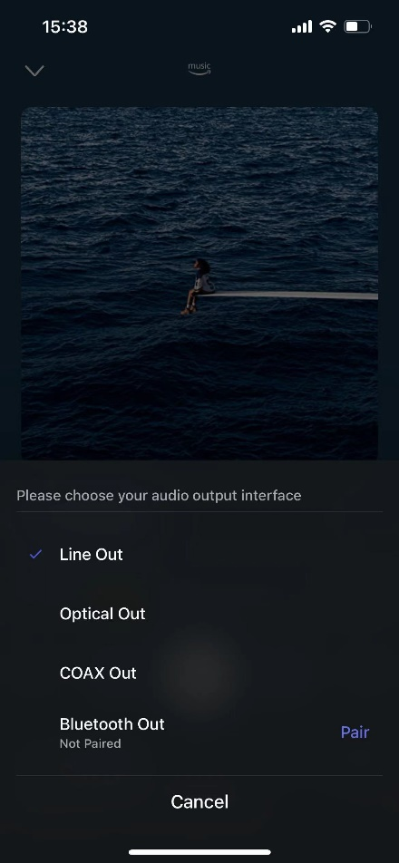

**Option 2: Select Audio Output Interface from Device Settings**

1. Open the WiiM Home app.
2. Navigate to the **Devices** tab.
3. Tap the **Device Settings** icon  of the WiiM Pro Plus.
4. Under the **Sound** section, tap **Audio Output**.
5. Select the output interface and adjust settings (e.g., Sample Rate Switch Latency for Optical/SPDIF Out).  
   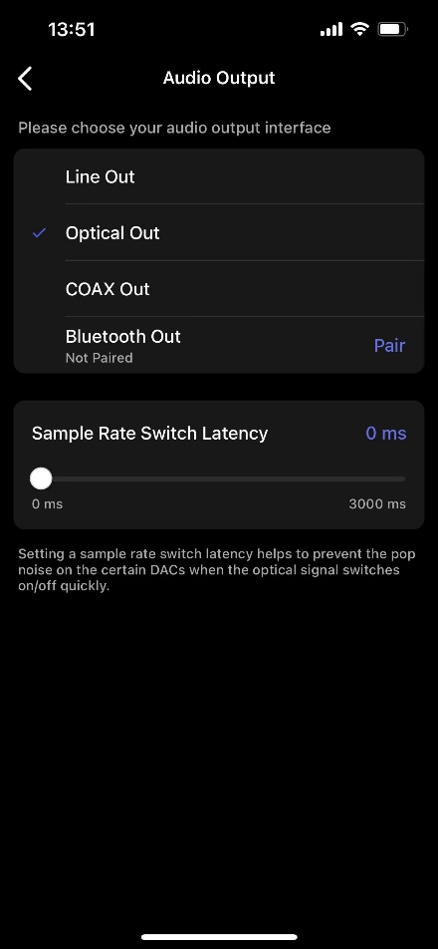

## Adjust Audio Output Settings

1. Open the WiiM Home app.
2. Navigate to the **Devices** tab.
3. Tap the **Device Settings** icon  of the WiiM Pro Plus.
4. Under the **Sound** section, select **Audio Settings**.
5. Adjust audio output settings depending on your preference and output interface:
   * + - Fixed Volume Output
       - Line Out Level
       - Volume Limit
       - SPDIF Output Resolution and Coax Output Resolution
       - Audio Channel
       - Volume Balance
       - Fade-In and Fade-Out effects

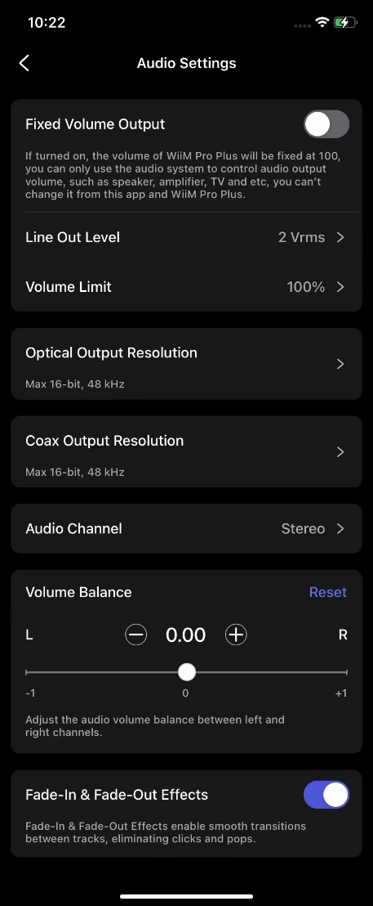

## Room Correction

You can use the Room Correction feature in the WiiM Home app to enhance audio quality by adapting to your room's unique acoustic properties. This feature minimizes unwanted audio issues such as echoes, reflections, and standing waves, delivering a more balanced and accurate listening experience.

For detailed instructions, see [Room Correction Guide](https://faq.wiimhome.com/en/support/solutions/articles/72000626583-optimizing-your-audio-experience-a-comprehensive-guide-to-room-correction).

## Equalizer (EQ)

You can enhance your audio experience with the Per-Source EQ feature in the WiiM Home app.

Choose from 24 preset EQ settings for quick adjustments, utilize the 10-band Graphic EQ (GEQ) for intuitive control, or fine-tune your sound with the 10-band Parametric EQ (PEQ) for precise and detailed customization.

For detailed instructions, see [EQ Guide](https://faq.wiimhome.com/en/support/solutions/articles/72000626485-how-to-use-per-source-eq-a-comprehensive-guide).

# Audio Output/Input via Bluetooth

## Audio Input via Bluetooth

With Bluetooth, you can stream tunes from various devices like smartphones, tablets, TVs, and laptops. To start streaming, first pair your device with the WiiM Pro Plus.

You can select any of the following options to pair your device with the WiiM Pro Plus:

* + **Option 1: Bluetooth Pairing Using Volume Buttons**

Press and hold the **Volume +** and **Volume –** buttons on the WiiM Pro Plus together for 2 seconds to initiate pairing mode.

* + **Option 2: Bluetooth Pairing Using WiiM Voice Remote**

Press and hold the **Play** button on the WiiM Voice Remote for 3 seconds to initiate pairing mode.

* + **Option 3: Bluetooth Pairing Using WiiM Home App**

If the WiiM Pro Plus is connected to your network, you can initiate Bluetooth pairing mode in the WiiM Home app by selecting **Bluetooth** as source input in the **Browse** tab.  
  
In this case, if there’s no device connected to the WiiM Pro Plus, the app will initiate pairing mode for the WiiM Pro Plus automatically.

***Note****: The Bluetooth feature is compatible with A2DP and AVRCP profiles, and supports both SBC and AAC codecs.*

## Audio Output via Bluetooth

You can use the WiiM Pro Plus as a Bluetooth source device, enabling seamless pairing with your Bluetooth speaker, headphone, or earphone.

Follow these steps to complete the Bluetooth pairing procedure for audio output:

1. Open the WiiM Home app on your iOS or Android device.
2. Select the **Devices** tab.
3. Tap the **Device Settings** icon  of the WiiM Pro Plus.
4. Select **Audio Output**, then tap **Pair** next to **Bluetooth Out** to initiate pairing.  
   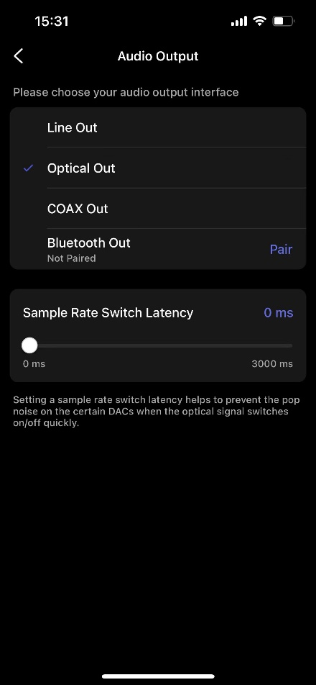
5. Select the desired external Bluetooth device (e.g., a speaker) to pair. 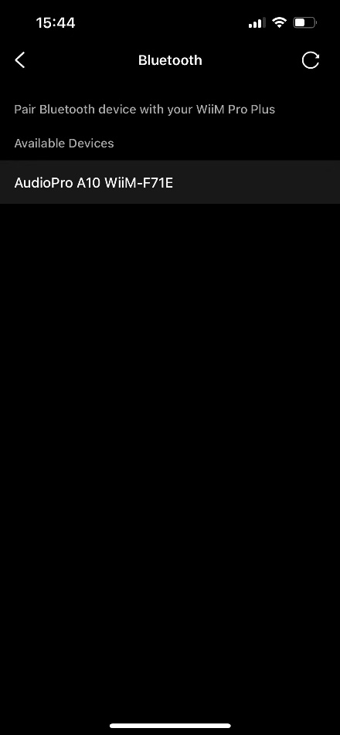

You can also complete this procedure by selecting the Bluetooth output from the **Now Playing** page. For details, see Select Audio Output Interface.

# Voice Control

Navigate and control the WiiM Pro Plus with voice commands to search, play, stop, or skip music and more.

The WiiM Pro Plus supports the following voice control services:

* + **Amazon Alexa**

Refer to [How to Use Amazon Alexa with Your WiiM Device](https://faq.wiimhome.com/en/support/solutions/articles/72000528773) for instructions.

* + **Siri**

Refer to [Using Siri to Play Music on Your WiiM Device](https://faq.wiimhome.com/en/support/solutions/articles/72000584112-using-siri-to-play-music-on-your-wiim-device) for instructions.

* + **Google Voice Assistant**

Refer to [How to Control WiiM Device via Google Assistant](https://faq.wiimhome.com/en/support/solutions/articles/72000618051-how-to-control-wiim-device-via-google-assistant) for instructions.

# Direct Control via Your Favorite App

You can stream from your favorite apps directly to your WiiM Pro Plus with the following approaches.

Depending on your mobile devices and music service, there may be multiple ways to stream from your music app to WiiM devices. For example, if you use the Spotify app on an iOS device, you can use either Spotify Connect or AirPlay 2. However, Spotify Connect gives you better audio quality compared with AirPlay 2 and liberate your phone for other tasks.

## Spotify Connect

Spotify Connect is a way of playing Spotify through your wireless-compatible device over Wi-Fi or Ethernet. That means you can play your favorite tunes anywhere in the house without the need for convoluted Bluetooth pairing between devices whenever you want to listen to music.

Spotify Connect works from smart phone, tablet or PC that functions as a remote control for Spotify. Both free and premium account are supported. For more information, visit [Spotify Connect](https://www.spotify.com/connect/).

Using Spotify Connect ensures the best audio quality and streaming experience on the WiiM Pro Plus.



**Multi-room and Stereo Pairing**

To use Spotify Connect for multi-room or stereo pairing, follow these instructions:

1. Group multiple WiiM devices in the WiiM Home app. For instructions, see WiiM Multi-room Audio/Stereo Pairing.
2. Stream Spotify to the grouped WiiM devices. The group name will match the group lead device.

**License Information**

The Spotify Software is subject to third-party licenses found here:

<https://www.spotify.com/connect/third-party-licenses>

## AirPlay 2

With the support of AirPlay 2, the WiiM Pro Plus turns your speaker into an AirPlay 2-enabled speaker to stream the music you love from iOS, Mac, and PC devices or stream audio from Apple TV. It’s an easy and affordable way to connect your Apple devices to your favorite audio equipment and upgrade it to an AirPlay 2 receiver.

**How to Use AirPlay 2**

AirPlay 2 lets you stream music from your iOS, Mac, PC, and Apple TV to the WiiM Pro Plus over Wi-Fi or Ethernet.

For instructions, refer to [How to Stream Audio with AirPlay on WiiM Devices](https://faq.wiimhome.com/en/support/solutions/articles/72000584708-how-to-stream-audio-with-airplay-on-wiim-devices).

**AirPlay 2 Multi-room Audio**

For instructions, refer to AirPlay 2 Multi-room Audio.

**Notes:**

* + *To use AirPlay 2, you need an Apple device running iOS 11.4 or later.*
  + *Your Apple device and WiiM device must be connected to the same Wi-Fi network.*
  + *For more information about AirPlay 2, visit* [*https://www.apple.com/airplay*](https://www.apple.com/airplay)*.*

## TIDAL Connect

TIDAL is a global music streaming platform bringing fans closer to artists through unique experiences and the highest sound quality. Stream your favorite music seamlessly from the TIDAL app straight to your devices in the highest possible quality.

TIDAL Connect allows you to stream music from the TIDAL app to compatible devices. It's similar to Apple AirPlay and Spotify Connect in that it lets users stream music to connected devices from within the app. This means you can use your smartphone or computer as a controller to play music on the WiiM Pro Plus.

**How to Use TIDAL Connect**

1. Launch the TIDAL app on your mobile device.
2. Play a song and go to the **Now Playing** screen.
3. Tap the **Cast** icon at the top right.
4. Select your WiiM device from the list.

## Amazon Music Cast (Alexa Cast)

Alexa Cast is a feature that allows you to play and control music on any of your Alexa devices from your Amazon Music iOS or Android app. You can discover all your Alexa devices from your music app. Your devices do not need to be on the same Wi-Fi network as your mobile device. You can target any device from anywhere. Once you pick a target device, the music you selected on your app will start playing on the chosen device. You can now follow along on your app. When you tap skip on your app, your device skips to the next track. Your app becomes a remote control for the device.

**WiiM Pro Plus and Alexa Cast**

The WiiM Pro Plus is one of the first devices that support Alexa Cast with bit-perfect output up to 192 kHz/24-bit. You can stream Amazon Music Ultra HD directly from the native Amazon Music to the WiiM Pro Plus, delivering the highest possible audio quality.

**How to Use Alexa Cast**

1. **Log In**: Ensure you are logged into your Amazon account for Alexa on the WiiM Home app.
2. **Update**: Have the latest version of the Amazon Music app.
3. **Cast Music**: On the **Now Playing** screen, tap the **Casting** icon in the top right.
4. **Select Device**: Choose the WiiM Pro Plus from the list.

**Control Options**

* + **Voice Control**: Use voice commands to control music on the device.
  + **App Control:** Switch between voice and app control for convenience.
  + **Stop Casting:** To stop casting and resume playing on your phone, open the device list and tap the **Disconnect** button.

**Amazon Alexa Multi-room Audio**

Amazon Alexa can also be used for multi-room audio, allowing you to play music in sync on multiple speakers from compatible brands and the WiiM Pro Plus using the Amazon Alexa app.

For detailed instructions, see Amazon Alexa Multi-room Audio.

## Google Cast Audio

Google Cast audio allows you to instantly stream your favorite music, radio, or podcasts from Google Cast-enabled apps on your mobile device to your speakers over Wi-Fi or Ethernet.

**Setting Up Google Cast**

1. **Enable Google Cast:**
   * Once you have set up the WiiM Pro Plus, enable Google Cast from the WiiM Home app.
2. **Stream Music:**
   * Open a compatible app (e.g., Spotify, Apple Music, TIDAL, Amazon Music, YouTube Music, Deezer) on your mobile device and tap the **Cast** button.
   * Select the WiiM Pro Plus and start streaming audio.
3. **Use Chrome Browser:**
   * Cast any audio from your Chrome browser by selecting the **Cast** option in the menu.

**Google Cast Multi-room Audio**

Google Cast can also be used for multi-room audio, allowing you to play music in sync on multiple speakers from compatible brands and WiiM Pro Plus using the Google Home app.

For detailed instructions, see Google Cast Multi-room Audio.

## DLNA

DLNA (Digital Living Network Alliance) sets standards for home networking devices to communicate and share media files seamlessly. The WiiM Pro Plus is a DLNA-compatible digital media renderer (DMR).

**How It Works**

When connected to the same network as your other DLNA devices or apps, the WiiM Pro Plus automatically appears in the menus of these networked components. Your computer and other media devices will discover and recognize the WiiM Pro Plus without any additional setup.

**Controlling and Streaming**

You can control the WiiM Pro Plus from other DLNA digital media players or controllers. Additionally, you can stream content from DLNA digital media servers directly to the WiiM Pro Plus, with no extra configuration required.

# All Music in One App

With the free WiiM Home app, you can control your content and WiiM devices from one place. The app supports many popular music streaming services such as Spotify, iHeartRadio, TIDAL, Amazon Music, SoundCloud, Qobuz, Pandora, Deezer, TuneIn, and more.

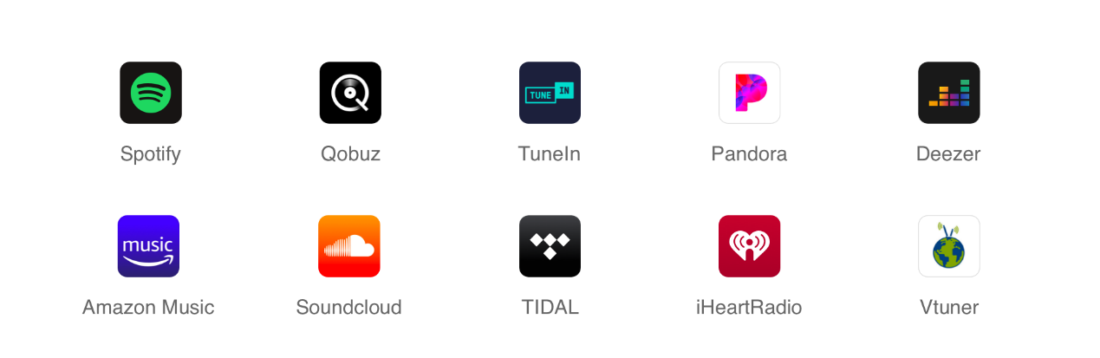

The WiiM Home app offers the follow features:

* **Stream from Any Source**: Enjoy seamless playback from streaming services, NAS, or other connected storage.
* **All-in-One Control**: Manage your music services and devices effortlessly in a single app for complete, centralized control.
* **Customized Listening Experience**: Tailor your listening experience with adjustable EQ settings, sleep timers, and scheduled music alarms.
* **Effortless Discovery**: Instantly find and save your favorite tracks using WiiM’s universal search, scanning through all your music sources.
* **Whole Home Music**: Enjoy multi-room music by grouping devices for synchronized playback or play different music on each speaker.
* **Built-in Support Center Access**: Quickly access our Support Center directly within the app, giving you instant assistance whenever you need it.

For more information, refer to [WiiM Home App User Manual](https://wiimhome.com/pdf/WiiM%20Home%20App%20User%20Guide.pdf).

# Multi-room Audio and Stereo Pairing

With the WiiM Pro Plus, it’s easy to build your wireless multi-room sound system with other AirPlay 2 speakers, Amazon Echo (or Alexa built-in devices) or Google Home. You can create an even more flexible multi-room sound system with multiple WiiM devices and your existing audio devices.

**Notes:**

* + *Alexa and Google Cast multi-room must be set up using the Alexa app and Google Home app, respectively.*
  + *Alexa and Google Cast multi-room features support network-based music services only.*
  + *To enable multi-room audio for other input sources, such as* ***Line-In****,* ***SPDIF-In****, or* ***Bluetooth****, the multi-room group must consist exclusively of WiiM devices.*

## WiiM Multi-room Audio/Stereo Pairing

With our proprietary multi-room technology, the WiiM Pro Plus supports all types of audio inputs—Wi-Fi/Ethernet, Bluetooth, analog Line In, digital SPDIF In—as sources for your multi-room system.

**WiiM Multi-room Setup**

For example, to set up a multi-room system with the **Line In** source input, follow the steps below:

1. Insert the line-in cable into the **Line In** port on the WiiM Pro Plus.
2. Connect the other end of the cable to the **Line Out** port on your source device, e.g. a record player.
3. Open the WiiM Home app.
4. Go to the **Browse** tab, then under the **Source Input** section, select **Line In** as the audio source.
5. Set up a multi-room music group with the WiiM Pro Plus:
6. Go to the **Devices** tab and select the WiiM Pro Plus connected to your sourcedevice.
7. Tap the **Group** icon  in the upper right corner of the device box.
8. Choose other desired WiiM devices to include in the multi-room audio group.

Now, the music from the connected device will play across your multi-room music group.

You can follow the same procedure to set up a WiiM multi-room system with any other source input supported by your source device.

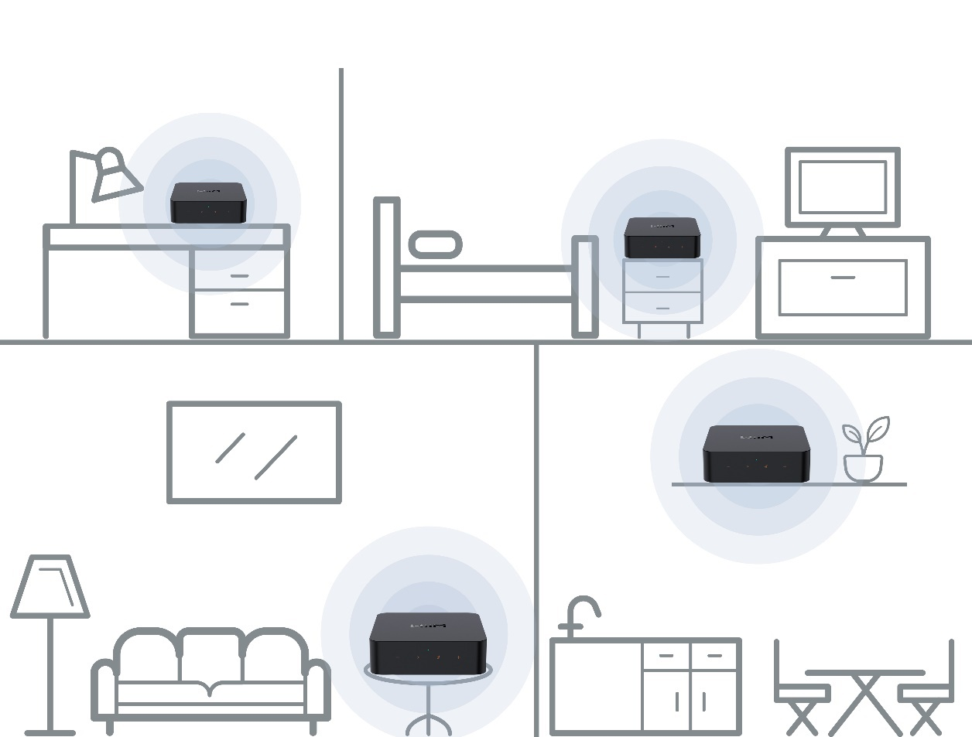

**WiiM Stereo Pairing**

In addition, you can group two speakers connected to two WiiM devices as a stereo pair for a wider, more immersive sound stage. This feature supports all input options, ensuring compatibility with virtually every music listening preference.

To use stereo pairing, follow the steps below:

1. Set up two WiiM devices.
2. Open the WiiM Home app.
3. Select a WiiM device and tap the **Group** icon  in the upper right corner.
4. Select the other WiiM device, then tap **Done**.
5. Tap the  icon and set the two WiiM devices to **L** and **R**, respectively.
6. Go to the **Browse** tab, then select your music to play.

## AirPlay 2 Multi-room Audio

For instructions, refer to [How to Add Multi-room Audio to Your WiiM Devices with AirPlay](https://faq.wiimhome.com/en/support/solutions/articles/72000596651-how-to-add-multi-room-audio-to-your-multiple-wiim-devices-with-airplay-).

## Amazon Alexa Multi-room Audio

1. Open the Amazon Alexa app on your smartphone or tablet.
2. Tap **Devices** at the bottom of the screen.
3. Tap the **+** icon in the top right corner of the screen.
4. In the menu that appears, choose **Combine speakers,** then select **Multi-room music**.
5. Select the **Echo** and WiiM devices you want to include in your multi-room music setup, then tap **Next**.
6. Assign a group name for the multi-room music setup (e.g., "Bedroom").
7. Follow the on-screen prompts to complete the setup.

***Note****: When used with Amazon Echo or other Amazon devices, the WiiM Pro Plus functions as an audio receiver and cannot transmit its physical audio inputs (e.g.,* ***Line-In*** *or* ***SPDIF-In****) to these Amazon devices over Wi-Fi.*

## Google Cast Multi-room Audio

You can group the WiiM Pro Plus with other Google Home or Google Cast enabled devices to play the same music on all devices via the Google Home app.

1. Open the Google Home app.
2. Tap the **+** icon in the top left corner.
3. Tap **Create speaker group** to create a speaker group.
4. Select the devices that are in the same network.

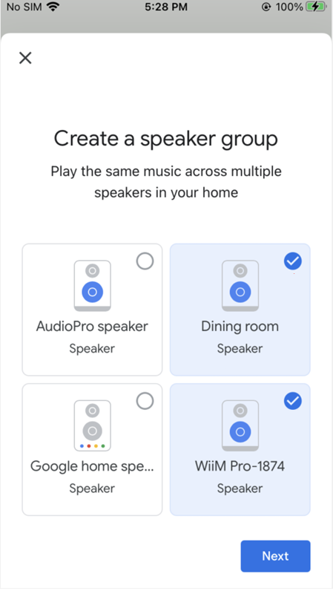

1. Assign a name to your group (e.g., "Living Room").
2. Stream music to the group.

***Note****: When using with Google Cast audio devices, the WiiM Pro Plus functions as an audio receiver and cannot transmit its physical audio inputs (e.g.,* ***Line-In*** *or* ***SPDIF-In****) to these Google Cast audio devices.*

# Advanced Features

## Firmware Updates

* The WiiM Pro Plus updates automatically when connected to your network
* Updates occur silently between 2:00 a.m. and 5:00 a.m. local time, with no sound or notifications during the process. Upon opening the app after the upgrade, you’ll see the latest updates applied to the WiiM Pro Plus.

## Use Ethernet Instead of Wi-Fi

When an Ethernet cable is connected, the WiiM Pro Plus will automatically switch off Wi-Fi to use the Ethernet network.

To confirm the active connection:

1. Open the WiiM Home app.
2. Go to the **Devices** tab and tap the **Device Settings** icon  of the WiiM Pro Plus.
3. Select **Network Status** to view the current network connection.

# FAQ and Support

## FAQ

If you experience problems with the audio streamer, try these solutions first:

* **What can I do if my WiiM Home app can’t find the device?**
* Make sure your network is available and the device is powered on properly.
* Check the LED on the device is solid white.
* Make sure your smartphone/tablet and WiiM Pro Plus are connected to the same Wi-Fi network.
* Make sure you have the latest version of the WiiM Home app on your device.
* Try restarting your smartphone/tablet, WiiM Pro Plus, and router.
* If still can’t find, reconfigure the device to the network.
* **What can I do if my device has no sound?**

If you are not getting any sound from your WiiM Pro Plus, make sure you have checked the following things:

* **Volume Levels**: Ensure that the volume is turned up both in the WiiM Home app and on your external device (e.g., AV receiver) connected to the WiiM Pro Plus.
* **Input Source**: Make sure the correct input source is selected on your receiver or device that corresponds to the output of the WiiM Pro Plus.
* **Audio Output Selection**: Confirm that the correct audio output is selected in the WiiM Home app.
* **Physical Connections**: Verify that all physical connections between the WiiM Pro Plus and your receiver or device are plugged in correctly and securely.
* **Audio dropout or no sound on AirPlay 2?**

If you experience no sound with AirPlay 2 but has sound with other service, follow these steps to troubleshoot the issue:

* **Check the music app**: Ensure the progress bar in the music app on your Apple device is moving during playback.
* **Check network connectivity**: Ensure the signal of your WiiM Pro Plus and your streaming device are strong. Move your WiiM Pro Plus and the streaming device closer to your wireless router or access point to improve the signal strength.
* **Restart your network devices**: Power cycle your router, modem, WiiM Pro Plus, and any streaming devices. This simple step can often resolve connectivity issues.
* **Update firmware and software**: Ensure that your WiiM Pro Plus and all devices involved in the AirPlay 2 setup have the latest firmware and software updates installed. Additionally, update your streaming device (e.g., iPhone, iPad, Mac) to the latest version of iOS, iPadOS or macOS.
* **Reset your WiiM Pro Plus**: As a last resort, you can try performing a factory reset on your WiiM Pro Plus and set it up again.
* **How can I reset my device?**
* Press and hold the **Play/Pause** button on the WiiM Pro Plus for 10 seconds until you will hear the voice prompts of “Restore to factory setting” and see the light flashing red and white.
* Factory reset clears all source, volume, and network settings for the WiiM Pro Plus and returns it back to the original factory settings.
* **What can I do if my device cannot power on normally?**
* Check the device LED status and ensure it’s on.
* Make sure to use the provided USB power adapter or a USB power adapter rated for 5V, 2A.

## Support

If you are unable to resolve your issue, please follow one of the methods below to reach out to us for assistance:

* **WiiM Home app**: Go to **More** > **Feedback** or **More** > **FAQ** to submit a ticket. You will receive email response from WiiM Support in the next 24 hours.
* **FAQ Website**: Find more FAQ at <https://faq.wiimhome.com/en/support/solutions>.
* **Email**: Send an email to [support@wiimhome.com](mailto:support@wiimhome.com) for assistance.
* **WiiM Pro Plus Support**: Visit <https://www.wiimhome.com/support/wiimPro>.

# Public Network Interfaces and Services

This chapter describes the public network interfaces (LAN, Wi-Fi, and Bluetooth) on the WiiM Pro Plus and the services they support.

## LAN Interface

The LAN interface allows the device to connect to a wired network via an Ethernet cable, providing a stable and high-speed connection for reliable streaming and control.

***Note****: When connected via Ethernet, the WiiM Pro Plus will automatically disable the Wi-Fi connection to prioritize the wired network. If the Ethernet cable is disconnected, the device will automatically reconnect to the Wi-Fi network.*

* + **Physical Port**: An RJ-45 Ethernet port (10/100 Mbps).
  + **Supported Protocols/Services**:
  + **DHCP**: By default, when connecting the WiiM Pro Plus to the LAN using an Ethernet cable, the device will automatically configure the network connection via DHCP (Dynamic Host Configuration Protocol) to obtain an IP address.
  + **mDNS**: Allows the WiiM Pro Plus to be discovered within the local network.
  + **UPnP/DLNA**: Enables media sharing and control with compatible devices.
  + **Configuration**: Once connected, you can view the connection status and adjust network settings using the WiiM Home app.  
    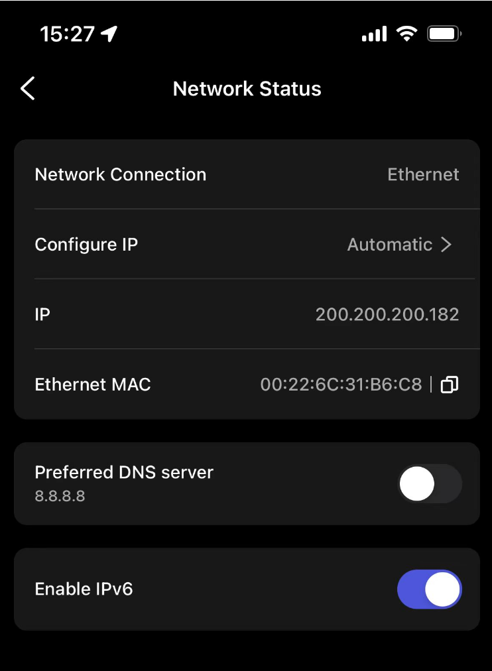

## Wi-Fi Interface

The Wi-Fi interface allows the device to connect to a wireless network, providing flexible setup and streaming options without the need for a wired connection.

* + **Supported Standards**: IEEE 802.11a/b/g/n/ac (2.4GHz and 5GHz bands)
  + **Supported Protocols/Services**:
  + **Wi-Fi Client Mode**: By default, the WiiM Pro Plus is set to Wi-Fi Client Mode, automatically connecting to a known Wi-Fi network.
  + **AP Mode**: Allows the WiiM Pro Plus to be set up via Wi-Fi. The AP mode is automatically enabled when the WiiM Pro Plus enters setup mode.
  + **mDNS**: Allows the WiiM Pro Plus to be discovered within the local network.
  + **UPnP/DLNA**: Enables media sharing and control with compatible devices.
  + **Configuration**: Once connected via Wi-Fi, check connection status and modify Wi-Fi settings using the WiiM Home app.   
    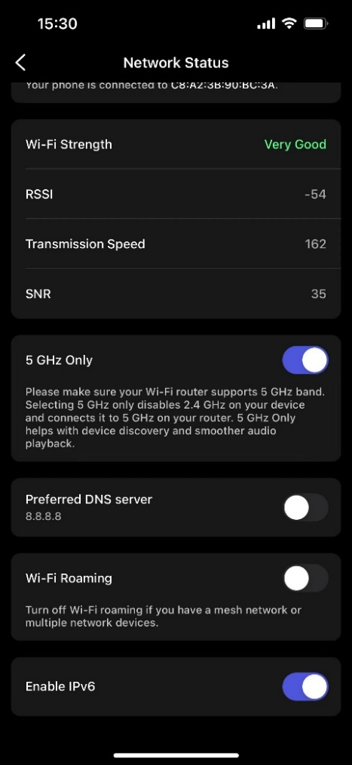

## Bluetooth Interface

The Bluetooth interface is used for both Wi-Fi setup and audio streaming.

* + **Supported Protocols/Services**: Bluetooth 5.0 LE (A2DP Sink and A2DP Source)
  + **BLE Broadcasting**: BLE broadcasting is automatically enabled during Wi-Fi setup, allowing the WiiM Home app to discover the device and connect it to the Wi-Fi network. For details, see WiiM Pro Plus Setup via Wi-Fi.
  + **A2DP Sink**: Supports receiving audio streams from mobile devices, tablets, etc., for audio playback via Bluetooth.
  + **A2DP Source**: Output audio to Bluetooth speakers or headphones for wireless audio streaming.
  + **Configuration**: Bluetooth pairing is required for audio streaming. For details, see Audio Output/Input via Bluetooth.

# Important Safety Instructions

1. Read these instructions carefully.
2. Keep these instructions for future reference.
3. Heed all warnings.
4. Follow all instructions.
5. Do not use this apparatus near water.
6. Clean only with a dry cloth.
7. Do not block any ventilation openings. Install in accordance with the manufacturer’s instructions.
8. Do not install near any heat sources such as radiators, heat registers, stoves, or other apparatus (including amplifiers) that produce heat.
9. Protect the power cord from being walked on or pinched particularly at plugs, convenience receptacles, and the point where they exit from the apparatus.
10. Only use attachments/accessories specified by the manufacturer.
11. Unplug this apparatus during lightning storms or when unused for long periods of time
12. Refer all servicing to qualified personnel. Servicing is required when the apparatus has been damaged in any way, such as external power supply, power-supply cord or plug is damaged, liquid has been spilled or objects have fallen into the apparatus, the apparatus has been exposed to rain or moisture, does not operate normally, or has been dropped.
13. To reduce the risk of fire or electrical shock, do NOT expose this product to rain, liquids or moisture.
14. Do NOT expose this product to dripping or splashing, and do not place objects filled with liquids, such as vases, on or near the product.
15. Keep the product away from fire and heat sources. Do NOT place naked flame sources, such as lighted candles, on or near the product.
16. Do NOT make unauthorized alterations to this product.
17. Do NOT use in vehicles or boats.
18. Use this product only with the power supply provided.
19. Where the mains plug or an appliance coupler is used as the disconnect device, the disconnect device shall remain readily operable.
20. Due to ventilation requirements, does not recommend placing the product in a confined space such as in a wall cavity or in an enclosed cabinet.
21. Contains small parts which may be a choking hazard. Not suitable for children under age 3.
22. This product contains magnetic material. Consult your physician on whether this might affect your implantable medical device.
23. Do not place or install the bracket or product near any heat sources, such as fireplaces, radiators, heat registers, or other apparatus (including amplifiers) that produce heat.

# CE/FCC Statements

**RF Exposure Information:** To maintain compliance with FCC RF exposure requirements, use the product that maintains a 20cm separation distance between the user's body and the host.

MPE limit for RF exposure at prediction frequency and satisfy RF exposure compliance.

**FCC Statement:**

This device complies with part 15 of the FCC rules. Operation is subject to the following two conditions:

(1) this device may not cause harmful interference, and

(2) this device must accept any interference received, including interference that may cause undesired operation.

NOTE: The manufacturer is not responsible for any radio or TV interference caused by unauthorized modifications or changes to this equipment. Such modifications or changes could void the user’s authority to operate the equipment.

NOTE: This equipment has been tested and found to comply with the limits for a Class B digital device, pursuant to part 15 of the FCC Rules. These limits are designed to provide reasonable protection against harmful interference in a residential installation. This equipment generates uses and can radiate radio frequency energy and, if not installed and used in accordance with the instructions, may cause harmful interference to radio communications. However, there is no guarantee that interference will not occur in a particular installation. If this equipment does cause harmful interference to radio or television reception, which can be determined by turning the equipment off and on, the user is encouraged to try to correct the interference by one or more of the following measures:

‐ Reorient or relocate the receiving antenna.

‐ Increase the separation between the equipment and receiver.

‐Connect the equipment into an outlet on a circuit different from that to which the receiver is connected.

‐Consult the dealer or an experienced radio/TV technician for help.

**CE Statement:**

RF exposure information: The Maximum Permissible Exposure (MPE) level has been calculated based on a distance of d=20 cm between the device and the human body. To maintain compliance with RF exposure requirement, use product that maintain a 20cm distance between the device and the human body.

Do not use the device in the environment at too high or too low temperature,

never expose the device under strong sunshine or too wet environment.

The suitable temperature for the product and accessories is 0℃-40℃.

**Operating frequency range and maximum transmit power**

Bluetooth: 2402MHz ~ 2480MHz, <9.11 dBm EIRP

WLAN 2.4GHz: 2412MHz ~ 2472MHz, <20 dBm EIRP

WLAN 5GHz: 5150MHz ~ 5825MHz, <20 dBm EIRP

The device for operation in the band 5150~5350 MHz is only for indoor use to reduce the potential for harmful interference to co-channel mobile satellite systems.

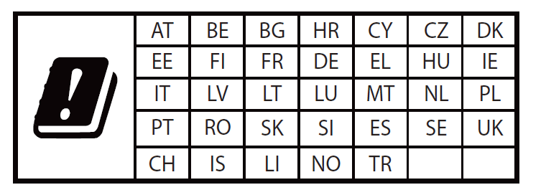

**This product can be used across EU member states.**

**EU Regulatory Conformance**

Hereby, Linkplay Technology Inc. Corporation declares that this device is in compliance with the essential requirements and other relevant provisions of Directive 2014/53/EU.



Este equipamento não tem direito à proteção contra interferência prejudicial e não pode causar interferência em sistemas devidamente autorizados.

Para maiores informações, consulte o site da ANATEL - [www.gov.br/anatel/pt-br/](http://www.gov.br/anatel/pt-br/).